

Requirement & Design Specification

**Computer Shop Management System (CyberBeat)**

**Version: 1.3.7**

– Hanoi, July 2025 –

# Record of Changes

| **Version** | **Date** | **A* M, D** | **In charge** | **Change Description** |
| --- | --- | --- | --- | --- |
| V1.0 | 20/5 | A | TaiDXHE190009 | Create context diagram and database |
| V1.1 | 22/5 | M | DangDNNHE180137 | Modify database |
| V1.2 | 26/6 | A | DangDNNHE180137 | Draw ScreenFLow |
| V1.2.1 | 12/7 | M | QuocDKHE180045 | Update Database |
| V1.2.2 | 18/7 | M | TaiDXHE190009 | Update context diagram |
| V1.3 | 22/7 | A | DangDNNHE180137 | Draw Screens Flow |
| V1.3.1 | 22/7 | A | QuocDKHE180045 | Draw ScreenFLow |
| V1.3.2 | 23/7 | A | TaiDXHE190009 | Screen author |
| V1.3.3 | 24/7 | M | DangDNNHE180137 | Modify database and Description Database |
| V 1.3.4 | 25/7 | M | DangDNNHE180137 | Modify Screens Flow |
| V 1.3.5 | 25/7 | A | QuocDKHE180045 | Draw Use Case Diagram |
| V 1.3.6 | 25/7 | M | TaiDXHE190009 | Modify ContextDiagram |
| V 1.3.7 | 25/7 | A | DangDNNHE180137 | Use Case Description and Actor |
|  |  |  |  |  |

*A - Added M - Modified D - Deleted

Contents

Record of Changes 2

I. Overview 4

1. System Context 4

2. User Requirements 4

2.1 Actors 4

2.2 Diagrams 5

2.3 Descriptions 6

3. System Functionalities 6

3.1 Screens Flow 6

3.2 Screen Authorization 6

3.3 Non-UI Functions 7

II. Functional Requirements 8

1. Feature Name1 8

1.1 SubFeature Name1.1 8

1.2 SubFeature Name1.2 8

2. User Authentication 8

2.1 User Register 8

2.2 User Login 8

2.3 Password Reset 8

2.4 User Profile 8

3. System Administration 9

3.1 Master Data 9

3.2 User Management 10

III. System Design 10

1. Database Design 10

1.1 Database Schema 10

1.2 Table Descriptions 10

2. Code Packages 11

2.1 Package Diagram 11

2.2 Package Descriptions 11

# I. Overview

## 1. System Context

*[Gives the overall description about the product with some introduction and the context diagram. The context diagram presents the boundary and connections between the system you’re developing and everything else in the universe. This identifies external entities (or terminators – software, hardware, human components, and other systems) outside the system that interface to it in some way, as well as data, control, and material flows between the terminators and the system.]*

<<Sample: The Cafeteria Ordering System is a new software system that replaces the current manual and telephone processes for ordering and picking up meals in the Process Impact cafeteria. The context diagram below illustrates the external entities and system interfaces for release 1.0. The system is expected to evolve over several releases, ultimately connecting to the Internet ordering services for several local restaurants and to credit and debit card authorization services.

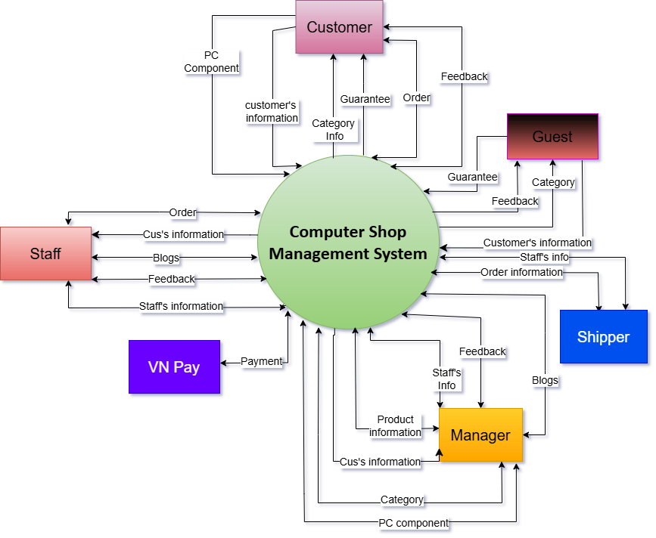

## 2. User Requirements

### 2.1 Actors

*[An actor is someone/something that interacts with the system.*

* *The only external entities that interact with the system*
* *﻿Actors are outside the system and not part of it*
* *﻿A user is an individual, whereas an actor represents the role played by all users of the same type*
* *There are other types of actors in addition to or in place of human actors: external systems, I/O devices, or timers*

*Following are some questions you might ask to help user representatives identify actors*

* *Who (or what) is notified when something occurs within the system?*
* *Who (or what) provides information or services to the system?*
* *Who (or what) helps the system respond to and complete a task?*

*This part gives the description of system actors, you can follow the table form as below]*

| **#** | **Actor** | **Description** |
| --- | --- | --- |
| 1 | Manager | Manager supervises the operations by accessing customer, staff, and product data. They make decisions based on system feedback and data and can post updates or changes through the system. |
| 2 | Staff | Staff are employees who interact with the system to manage customer and order information, post blogs, handle feedback, and perform administrative tasks. They contribute data and services to support system functionality. |
| 3 | Shipper | Shipper is responsible for processing delivery of orders. They receive order and customer information from the system, update shipping status, and provide feedback regarding logistics and shipment. |
| 4 | Customer | Customer is a registered user who interacts with the system to place orders, request warranty services, view categories, and provide feedback. Customers are notified of order status and provide personal and order-related information. |
| 5 | VN Pay | VN Pay is an external payment gateway system that processes financial transactions. It receives payment requests from the system and notifies the system about payment status and outcomes. |
| 6 | Guest | Guest is an unregistered user who can browse product categories and view warranty information. They can also provide feedback without having a system account. They represent anonymous visitors. |

### 2.2 Diagrams

*[A use case (UC) describes a sequence of interactions between a system and an external actor that results in the actor being able to achieve some outcome of value. The names of use cases are always written in the form of a verb followed by an object. Select strong, descriptive names to make it evident from the name that the use case will deliver something valuable for some user.*

*Following are some questions you might ask to help user representatives identify use cases*

* *What will the actor use the system for?*
* *Will the actor create, store, change, remove, or read data in the system?*
* *Will the actor need to inform the system about external events or changes?*
* *Will the actor need to be informed about certain occurrences in the system?*

*In this section, you need to provide the UC diagram(s) to show the actor-UCs and UC-UC relationships like the sample below. You can have multiple UC diagrams for the system, each diagram is for one actor or one workflow]*

#### 2.2.1 UCs for Customer

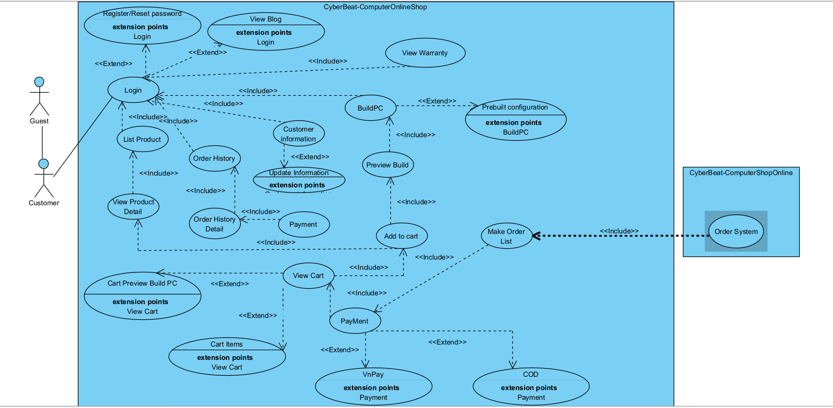

#### 2.2.2 UCs for Admin

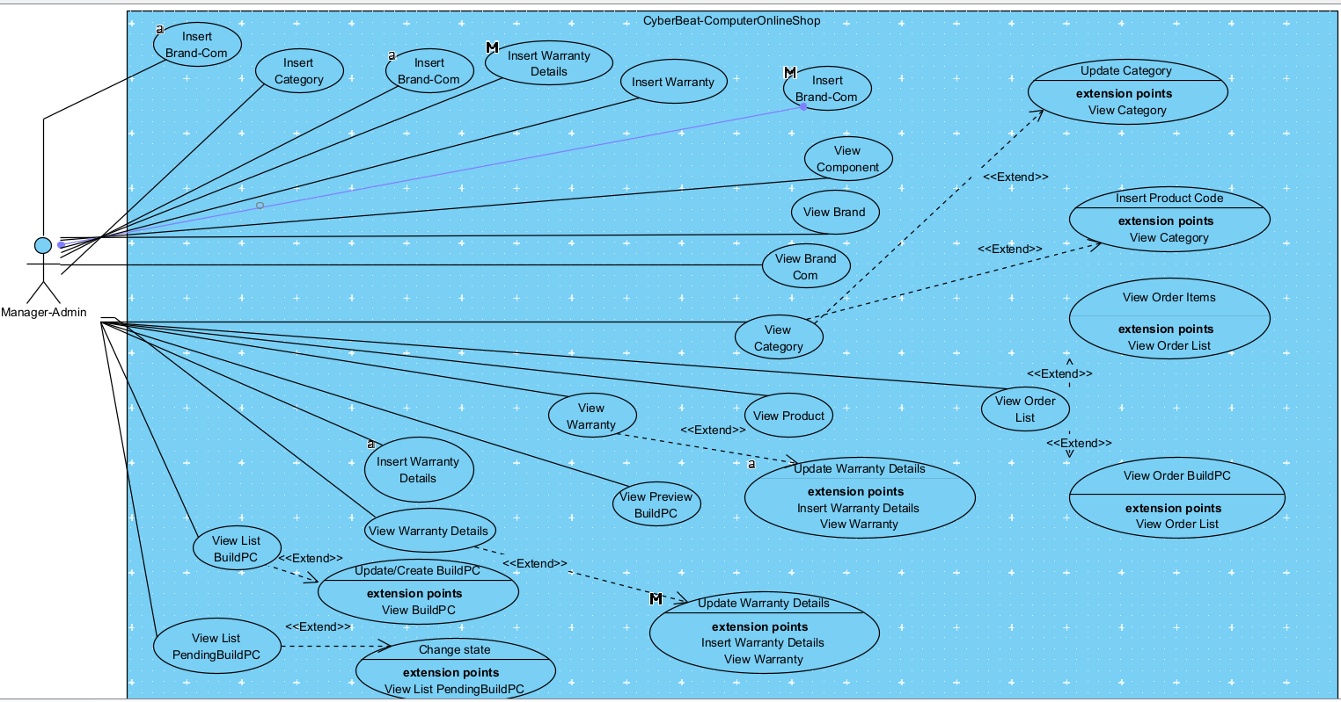

#### 2.2.3 UCs for Sales

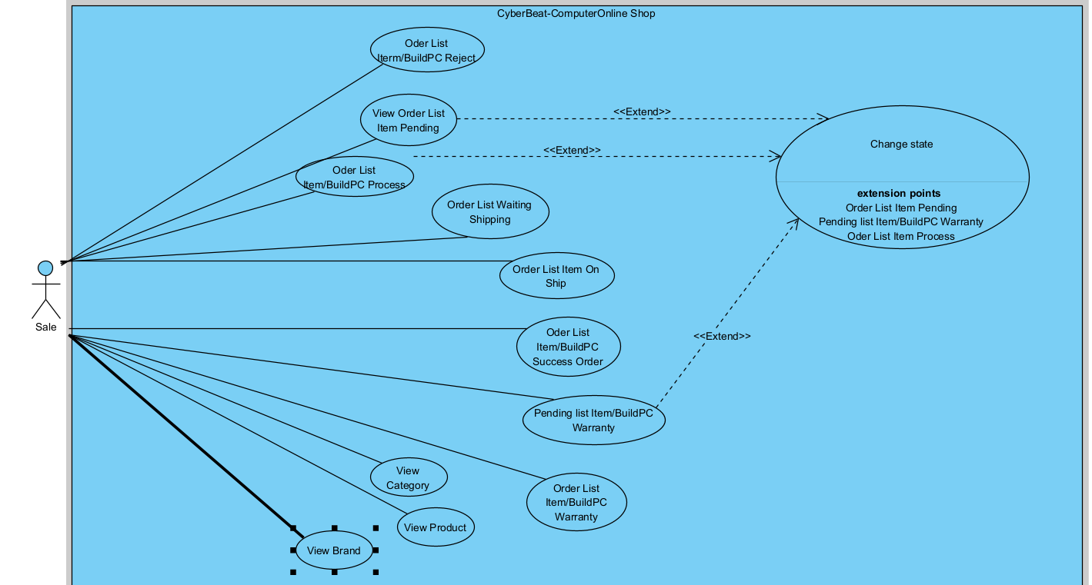

### 

### 

### 

### 2.3.4 USs for Shi

### 

### 

### 2.3 Descriptions

*[This part describes the use cases, you can follow the table form as below]*

## 

| ID | Use Case | Actor(s) | Use Case Description |
| --- | --- | --- | --- |
| 01 | Register User | Guest | As a new user, I want to register an account with my full information so that I can access customer functionalities like ordering or tracking orders. |
| 02 | Login | Guest, Customer | As a user, I want to log into the system using my account so that I can access features available to registered users. |
| 03 | View Products | Guest, Customer | As a user, I want to browse the product list and view details so that I can explore available components before purchasing. |
| 04 | Build PC | Customer | As a customer, I want to customize my own PC build from available components so that I can order a computer that meets my specific needs. |
| 05 | View Cart | Customer | As a customer, I want to review my selected items in the cart so that I can confirm or modify my order before payment. |
| 06 | Make Payment | Customer | As a customer, I want to pay using VNPay or COD so that I can complete my order with my preferred payment method. |
| 07 | Order History | Customer | As a customer, I want to view my past orders and their details so that I can track my purchases and warranties. |
| 08 | Update Information | Customer | As a customer, I want to update my personal and shipping information so that I can ensure my deliveries are accurate and up-to-date. |
| 09 | View Blog | Guest, Customer | As a user, I want to read blog content on the site so that I can gain insights and knowledge about technology and products. |
| 10 | View Warranty | Customer | As a customer, I want to view warranty information related to my products so that I can know the support or return policy details. |
| 11 | Insert Brand-Com | Manager-Admin | As an admin, I want to insert new brand-component combinations so that the system has updated inventory relationships. |
| 12 | Insert Category | Manager-Admin | As an admin, I want to insert new product categories so that customers can shop by clearly defined groups. |
| 13 | Insert Warranty | Manager-Admin | As an admin, I want to define new warranty programs so that purchased products are covered appropriately. |
| 14 | Insert Warranty Details | Manager-Admin | As an admin, I want to provide warranty details per brand-component so that customers know the coverage of each product. |
| 15 | Update Category | Manager-Admin | As an admin, I want to update product category information so that catalog details remain accurate and current. |
| 16 | Update Warranty Details | Manager-Admin | As an admin, I want to update warranty detail records so that outdated or incorrect data can be corrected. |
| 17 | View Component / Brand / BrandCom | Manager-Admin | As an admin, I want to view component, brand, and their relations so that I can verify the available inventory and associations. |
| 18 | View Order List | Manager-Admin | As an admin, I want to view all customer orders so that I can monitor, manage, and assign responsibilities. |
| 19 | View BuildPC | Manager-Admin | As an admin, I want to view the details of BuildPC configurations so that I can assess custom orders and related inventory. |
| 20 | Update BuildPC | Manager-Admin | As an admin, I want to update BuildPC records so that I can reflect changes in components or pricing. |
| 21 | Order List Item/BuildPC Reject | Sale | As a sales staff, I want to view rejected orders so that I can track failures and handle customer complaints. |
| 22 | Order List Item Pending | Sale | As a sales staff, I want to view pending orders so that I can follow up and change their state accordingly. |
| 23 | Order List Item/BuildPC Process | Sale | As a sales staff, I want to see which orders are currently in processing so that I can manage workload and support logistics. |
| 24 | Order List Waiting Shipping | Sale | As a sales staff, I want to track orders waiting for shipment so that I can prepare documents and coordinate delivery. |
| 25 | Order List Item On Ship | Sale | As a sales staff, I want to view orders that are currently being shipped so that I can provide accurate status to customers. |
| 26 | Order List Item/BuildPC Success Order | Sale | As a sales staff, I want to access successfully delivered/completed orders so that I can archive them or initiate warranty tracking. |
| 27 | Pending List Item/BuildPC Warranty | Sale | As a sales staff, I want to view pending warranty items so that I can assign and follow up warranty resolution tasks. |
| 28 | Order List Item/BuildPC Warranty | Sale | As a sales staff, I want to view all warranty cases so that I can monitor ongoing and completed warranty services. |
| 29 | Change Order State | Sale | As a sales staff, I want to change the status of orders (pending, processing, warranty) so that I can update the system and notify customers. |
| 30 | View Product/Category/Brand | Sale | As a sales staff, I want to browse product, brand, and category data so that I can assist customers and verify stock. |
| 31 | Order List Item Waiting Ship | Shipper | As a shipper, I want to view the list of orders that are waiting to be shipped so that I can prepare for delivery. |
| 32 | Order List Item On Shipping | Shipper | As a shipper, I want to view the list of orders currently in shipping so that I can track and manage their transportation progress. |
| 33 | Order List BuildPC On Ship | Shipper | As a shipper, I want to view custom BuildPC orders that are currently on delivery so that I can ensure the items are properly handled during shipping. |
| 34 | Change Shipping State | Shipper | As a shipper, I want to update the shipping status of regular and BuildPC orders so that customers and admins can track real-time delivery progress. |

## 

## 3. System Functionalities

*[Provide functionality overview of software system: screen flow, screen descriptions, system user roles, screen authorization, non-screen functions, ERD]*

### 3.1 Screens Flow

*[This part shows the system screens and the relationship among screens. You can draw the Screens Flow for the system in the form of diagram as below.]*

#### 3.1.1 Screens Flow of HomePages

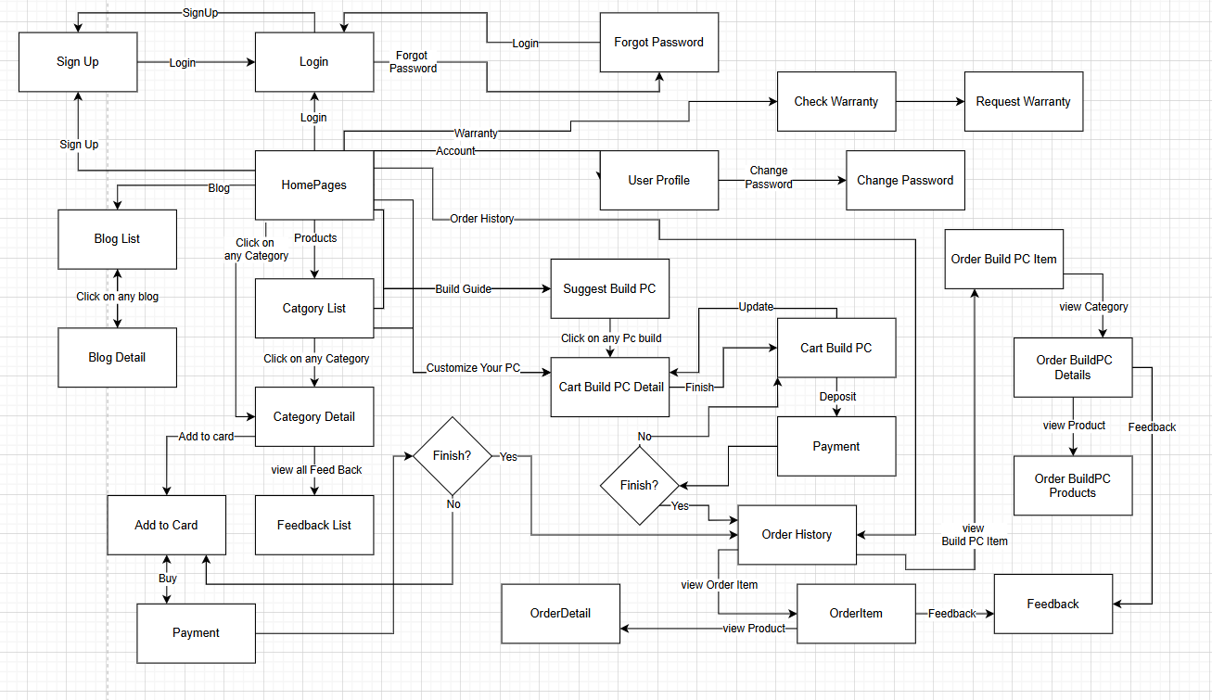

#### 3.1.2 Screens Flow of Admin

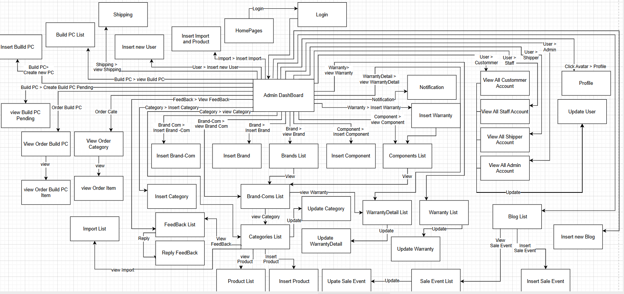

#### 3.1.3 Screens Flow of Sale

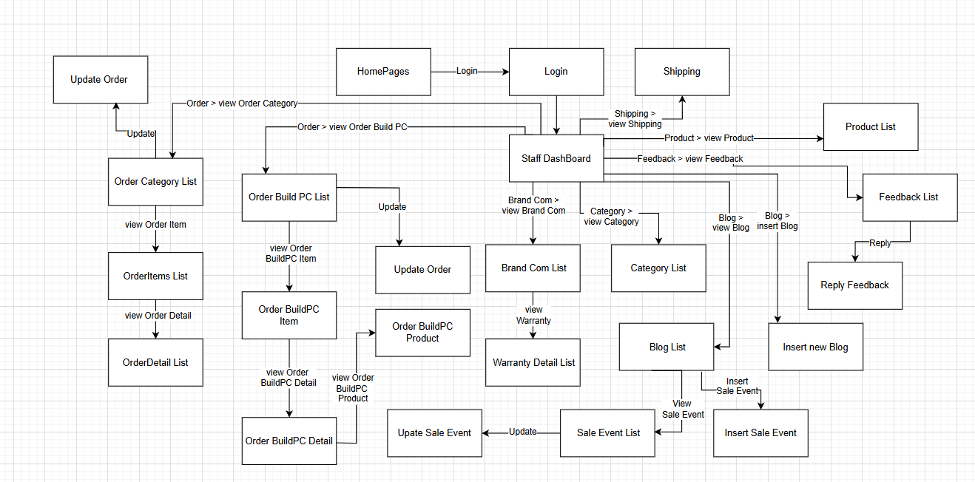

#### 3.1.4 Screens Flow of Shipper

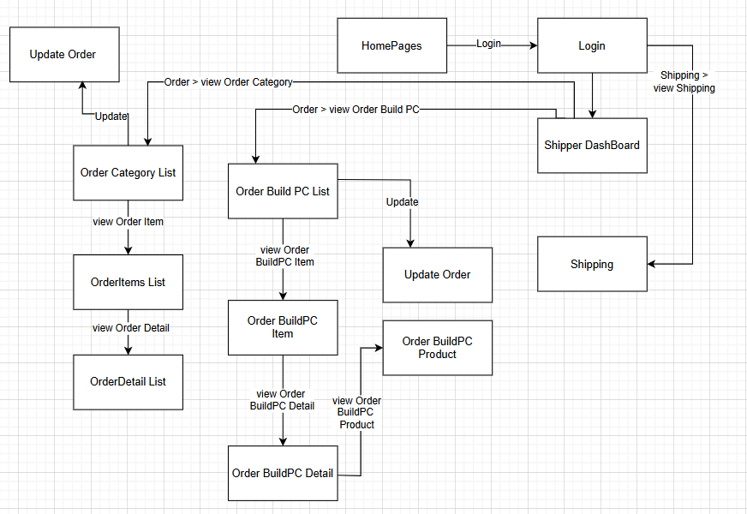

### 3.2 Screen Authorization

*[Provide the system roles authorization to the system features (down to screens, and event to the screen activities if applicable) in the table form as below – replace Role-Name1, Role-Name2,… with your specific system user role names]*

| **Screen** | **Manager** | **Sale** | **Customer** | **Shipper** | **Guest** |
| --- | --- | --- | --- | --- | --- |
| Sign up |  |  |  |  | X |
| Login | X | X | X | X |  |
| Forgot Password | X | X | X | X |  |
| HomePages | X | X | X |  | X |
| Blog list | X | X | X |  | X |
| Category list | X | X | X |  | X |
| Category Detail | X | X | X |  | X |
| Cart |  |  | X |  |  |
| Checkout |  |  | X |  |  |
| Customer Profile |  |  | X |  |  |
| Change Password | X | X | X | X |  |
| Suggest Build PC |  |  | X |  |  |
| Cart Build PC Detail |  |  | X |  |  |
| Payment |  |  | X |  |  |
| Order History |  |  | X |  |  |
| Order Item |  |  | X |  |  |
| Order Build PC Item |  |  | X |  |  |
| Order Build PC details |  |  | X |  |  |
| Order Build PC Products |  |  | X |  |  |
| Edit feedback |  |  | X |  |  |
| Admin Dashboard | X |  |  |  |  |
| Insert import and Product | X |  |  |  |  |
| Create new Staff account | X |  |  |  |  |
| View users infor | X |  |  |  |  |
| View brand | X |  |  |  |  |
| Insert brand | X |  |  |  |  |
| View Component | X |  |  |  |  |
| Insert new component | X |  |  |  |  |
| View Bra-com | X |  |  |  |  |
| Insert Bra-com | X |  |  |  |  |
| View Category | X |  |  |  |  |
| Insert Category | X |  |  |  |  |
| View Product | X |  |  |  |  |
| View Warranty | X |  |  |  |  |
| Insert Warranty | X |  |  |  |  |
| View Warranty Detail | X |  |  |  |  |
| Insert Warranty Detail | X |  |  |  |  |
| Rejected Order | X | X |  | X |  |
| Pending Order | X | X |  | X |  |
| In process Order | X | X |  | X |  |
| Waiting Ship Order | X | X |  | X |  |
| On shipping Order | X | X |  | X |  |
| Success Order | X | X |  | X |  |
| Order in Warranty | X | X |  | X |  |
| Pending warranty Order | X | X |  | X |  |
| Reject build PC order | X | X |  | X |  |
| In process build PC order | X | X |  | X |  |
| Waiting Ship build PC order | X | X |  | X |  |
| On shipping build PC order | X | X |  | X |  |
| Success build PC order | X | X |  | X |  |
| Pending Warranty builc PC order | X | X |  | X |  |
| On Warranty Order | X | X |  | X |  |
| View Feedback | X | X |  |  |  |
| Update Feedback | X | X |  |  |  |
| View Blogs | X | X |  |  |  |
| Insert new Blogs | X | X |  |  |  |
| View Sale Event | X | X |  |  |  |
| Insert Sale Events | X |  |  |  |  |
| View PC List | X |  |  |  |  |
| Waiting PC-Pending | X |  |  |  |  |
| Create new PC | X |  |  |  |  |
| Staff profile | X | X |  | X |  |

# **II. Functional Requirements**

*[Provide descriptions about the system’s functions/screens. The functions/screens are grouped by the system features, and even sub-features if needed. For the screens, you need to provide the screen layouts (mock-up screens) and relevant specifications if needed]*

## **1. Common**

### 1.1 Login

#### 1.1.1 Login Screen

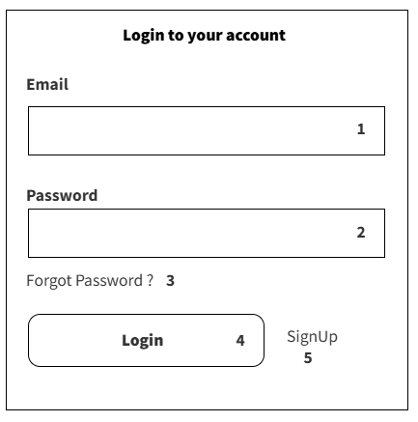

#### **This screen allows the User to:**

* ***Enter Login Credentials****:  
   Input their email address and password in the respective fields to log in securely.*
* ***Access Password Recovery****:  
   Click the "Forgot Password?" link to initiate a password reset process via registered email.*
* ***Submit Login Form****:  
   Click the* ***Login*** *button to authenticate and access the system dashboard.*
* ***Register a New Account****:  
   Click the* ***SignUp*** *link to navigate to the registration screen if they don’t have an account.*

**Field Description**

| **Field Name** | **Description** |
| --- | --- |
| (1) | Description: email input field  Functions: accepts email, validates format |
| (2) | Description: password input field  Functions: accepts password, masks input |
| (3) | Description: forgot password link  Functions: redirects to password recovery |
| (4) | Description: login button  Functions: submits credentials, authenticates user |
| (5) | Description: signup link  Functions: redirects to registration page |

#### 

### 1.2 Forget Password/Change Password

#### 1.2.1 Forget Password Screen

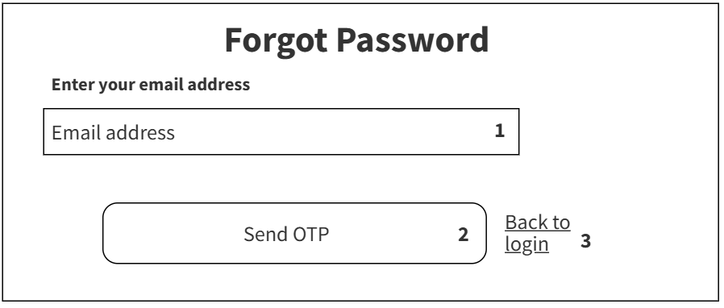

**This screen allows the User to:**

**Enter Login Credentials:** Input their email address and password in the respective fields to log in securely.

**Access Password Recovery:** Click the **"Forgot Password?"** link to initiate a password reset process via registered email.

**Submit Login Form:** Click the **Login** button to authenticate and access the system dashboard.

**Register a New Account:** Click the **SignUp** link to navigate to the registration screen if they don’t have an account.

**Field Description**

| **Field Name** | **Description** |
| --- | --- |
| (1) | Description: email input field  Functions: accepts email, validates format |
| (2) | Description: send OTP button  Functions: sends one-time password, initiates reset |
| (3) | Description: back to login link  Functions: redirects to login page |

### 1.3 OTP

#### 1.3.2 Change Password Screen

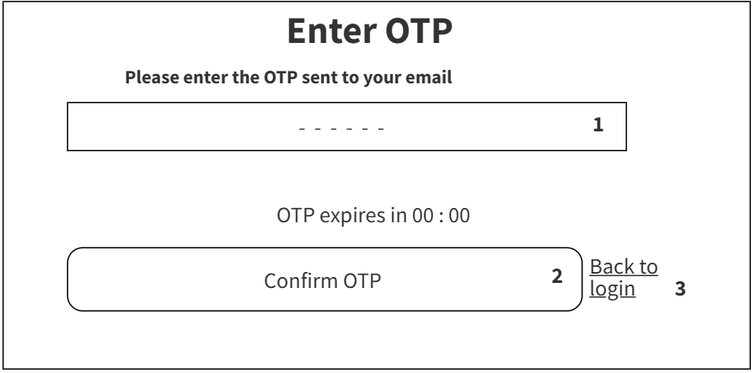

**This screen allows the User to:**

**Enter OTP:** Input the one-time password (OTP) received via email into the designated field for verification.

**Confirm OTP:** Click the "Confirm OTP" button to validate the entered code and proceed with the process.

**Back to Login:** Click the "Back to login" link to return to the login screen if needed.

**Field Description**

| **Field Name** | **Description** |
| --- | --- |
| (1) | Description: enter code input field  Functions: accepts verification code, validates format |
| (2) | Description: submit button  Functions: submits code, authenticates user |
| (3) | Description: back to menu link  Functions: redirects to menu screen |

### 1.4 Change Password

#### 1.4.1 Enter OTP Screen

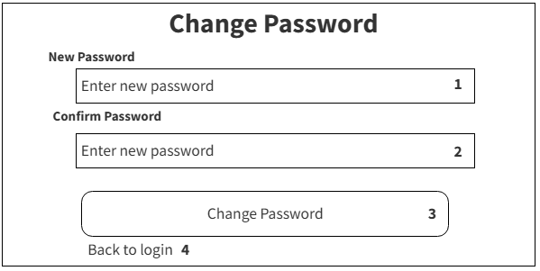

### **This screen allows the User to:**

**1. New Password:** Enter a new password into the input field.

**2. Confirm Password:** Re-enter the same password to confirm and ensure both entries match.

**3. Change Password:** Click this button to submit the new password. If the passwords match and meet the required criteria, the system will update the user’s password.

**4. Back to Login:** Click this link to return to the login screen without making any changes.

**Field Description**

| **Field Name** | **Description** |
| --- | --- |
| (1) | Description: new password input field  Functions: accepts new password, validates strength |
| (2) | Description: confirm password input field  Functions: accepts re-entered password, checks match |
| (3) | Description: change password button  Functions: submits new password, updates account |
| (4) | Description: back to login link  Functions: redirects to login page |

### 1.5 Sign up

#### 1.5.1 Sign up Screen

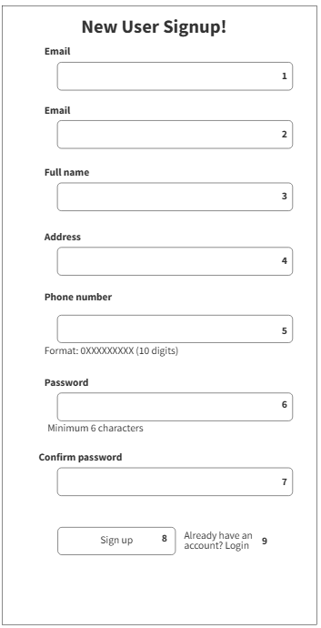

### **Login Screen**

This screen allows the User to:

* **Enter Login Credentials:** Input their email address and password in the respective fields to log in securely.
* **Access Password Recovery:** Click the **“Forgot Password?”** link to initiate a password reset process via the registered email.
* **Submit Login Form:** Click the **“Login”** button to authenticate and access the system dashboard.
* **Register a New Account:** Click the **“Sign Up”** link to navigate to the registration screen if they don’t have an account.

**Field Description**

| **Field Name** | **Description** |
| --- | --- |
| (1) | Description: email input field  Functions: accepts email, validates format |
| (2) | Description: full name input field  Functions: accepts user’s full name |
| (3) | Description: address input field  Functions: accepts user’s address |
| (4) | Description: phone number input field  Functions: accepts phone number, validates 10-digit format (0XXXXXXXXX) |
| (5) | Description: password input field  Functions: accepts password, enforces minimum 6 characters |
| (6) | Description: confirm password input field  Functions: accepts re-entered password, checks match |
| (7) | Description: sign up button  Functions: submits registration form, creates new account |
| (8) | Description: login link  Functions: redirects to login page for existing users |

## 

## 2. Shopping

### 2.1 HomePages Screen

#### 2.1.1 Home Screen

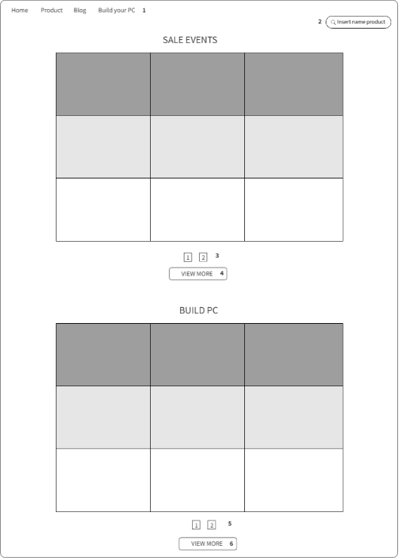

**Brand Selection Screen**

This screen allows the User to:

**Choose Entries per Page:** Select how many brand items to view on one page using the dropdown list (e.g., 5, 10, 25, 50, 100).

**Search for a Brand:** Enter keywords in the search box to quickly find specific brand records based on brand name or other details.

**Sort Brand Listings:** Click the sorting icons on the table headers to organize the list by **BrandID**, **Brand Name**, **Component Name**, **Quantity**, **View Category**, or **View Warranty**.

**Navigate Between Pages:** Use the pagination controls at the bottom to move between multiple pages of brand listings.

**View Brand Categories:** Click the “View Category” link to see detailed information about the category that each brand belongs to.

**Check Warranty Information:** Click the “View Warranty” link to review the warranty details associated with the brand's components.

**Field Description**

| **Field Name** | **Description** |
| --- | --- |
| (1) | Description: navigation menu  Functions: links to Home, Product, Blog, Build your PC pages |
| (2) | Description: expandable category list  Functions: expands to show main categories (PC, MAINBOARD, CPU, GPU, RAM, SSD, CASE) with a "+" button; clicking "+" reveals sub-layers (e.g., ASUS, MSI under MAINBOARD; AMD, INTEL under CPU; etc.), and clicking those sub-options filters products like brand buttons |
| (3) | Description: brand list section  Functions: displays buttons (ASUS, MSI, GIGABYTE, INTEL, AMD, NVIDIA, COSAIR, KINGSTON, SAMSUNG, DEEPCOOL, WESTERNDIGITAL) to show product |
| (4) | Description: minimum price input field  Functions: sets minimum price filter |
| (5) | Description: maximum price input field  Functions: sets maximum price filter |
| (6) | Description: search by price button  Functions: filters products by price range |

### 2.2 Cart Screen

#### 2.2.1 Add to CartItems Screen

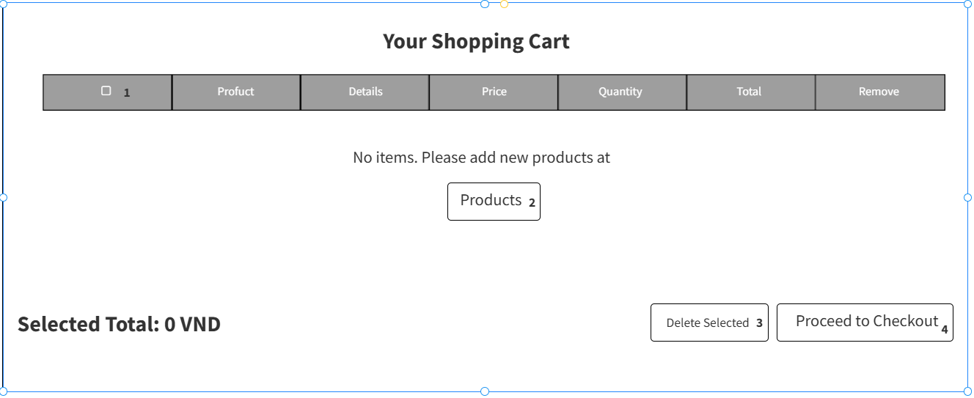

This screen allows the User to:

* **View Cart Contents**: Display a table listing all selected products with columns for selection (checkbox), product name, details, price, quantity, total cost, and a remove option.
* **Add Products**: Navigate to the "Products" section to add new items to the cart when it is empty, indicated by the "No items. Please add new products at Products" message.
* **Edit Quantity**: Adjust the quantity of each product in the cart to update the total cost.
* **Remove Items**: Delete individual products by using the "Remove" button or remove selected items using the "Delete Selected" button.
* **Check Total**: View the "Selected Total" to see the current total cost in VND, which updates based on selected or modified items.
* **Proceed to Checkout**: Click the "Proceed to Checkout" button to move forward with the payment process once items are added.

**Field Description**

| **Field Name** | **Description** |
| --- | --- |
| (1) | Description: product selection checkbox  Functions: allows checking (✓) to select a product |
| (2) | Description: product details button  Functions: displays available products when clicked |
| (3) | Description: clear selection button  Functions: removes selections made via checkbox (1) |
| (4) | Description: proceed to checkout button  Functions: advances to payment process |

### 

#### 2.2.2 Add to CartPC Screen

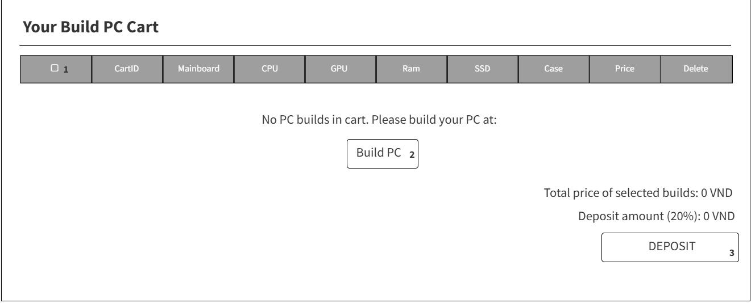

This screen allows the User to:

* **View PC Builds**: Display a table listing PC builds with columns for selection (checkbox), CartID, Mainboard, CPU, GPU, Ram, SSD, Case, Price, and a Delete option.
* **Add PC Builds**: Navigate to the "Build PC" section to create and add new PC configurations when the cart is empty, indicated by the "No PC builds in cart. Please build your PC at:" message with a "Build PC" link.
* **Select Builds**: Use the checkbox to select specific PC builds for further actions like deletion or deposit.
* **Delete Builds**: Remove individual PC builds using the "Delete" button or remove selected builds collectively.
* **Check Total Price**: View the "Total price of selected builds" to see the current total cost in VND, which updates based on selected builds.
* **Make Deposit**: Click the "DEPOSIT" button to pay a 20% deposit amount (calculated as 20% of the total price) for the selected builds.

**Field Description**

| **Field Name** | **Description** |
| --- | --- |
| (1) | Description: product selection checkbox  Functions: allows checking (✓) to select a product |
| (2) | Description: product details button  Functions: displays available products when clicked |
| (3) | Description: deposit button  Functions: processes a deposit payment for selected products from checkbox (1) |

## **3. Category Management**

#### 3.1 Category Screen

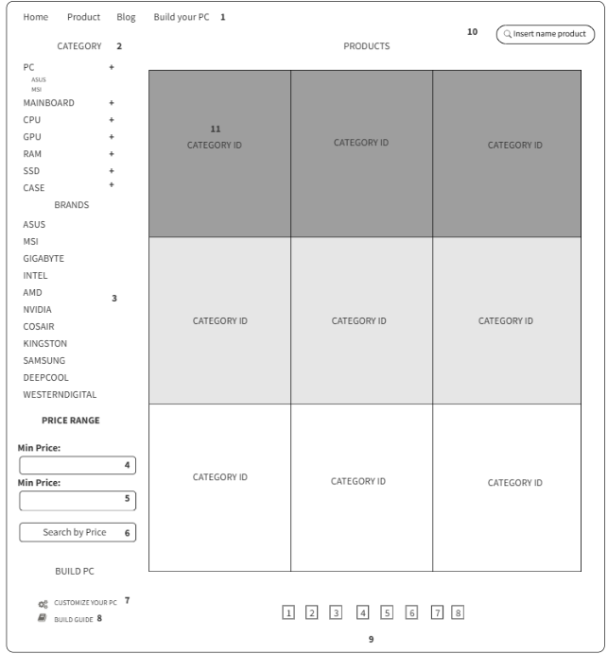

This screen allows the User to:

**View Product Categories**: Display a categorized list of products under main categories (e.g., MAINBOARD, CPU, GPU, RAM, SSD, CASE) with sub-categories and brands.

**Select Categories and Brands**: Choose specific categories or brands (e.g., ASUS, MSI, GIGABYTE, INTEL, AMD, NVIDIA, COSAIR, KINGSTON, SAMSUNG, DEEPCOOL, WESTERNDIGITAL) to filter products.

**Set Price Range**: Define a price range using minimum and maximum price inputs to filter products within that range.

**Search Products**: Enter keywords in the search box to find specific products by name or details.

**Navigate Products**: Use pagination controls at the bottom to move between multiple pages of product listings.

**Build PC**: Access the "Build PC" section to customize and create a new PC configuration.

**Customize PC**: Use the "Customize Your PC" link to start a personalized PC building process.

**Insert Product Name**: Input a product name in the designated field to search or add a specific product.

**Sort Products**: Organize the product list by clicking on category or brand headers (if applicable) to sort by Category ID or other criteria.

**View Product Details**: Click on product categories or brands to view detailed information about available products.

**Initiate Build Process**: Click the "Build" button to start assembling a PC with selected components.

**Field Description**

| **Field Name** | **Description** |
| --- | --- |
| (1) | Description: navigation menu  Functions: links to Home, Product, Blog, Build your PC pages |
| (2) | Description: expandable category list  Functions: expands to show main categories (PC, MAINBOARD, CPU, GPU, RAM, SSD, CASE) with a "+" button; clicking "+" reveals sub-layers (e.g., ASUS, MSI under MAINBOARD; AMD, INTEL under CPU; etc.), and clicking those sub-options filters products like brand buttons |
| (3) | Description: brand list section  Functions: displays buttons (ASUS, MSI, GIGABYTE, INTEL, AMD, NVIDIA, COSAIR, KINGSTON, SAMSUNG, DEEPCOOL, WESTERNDIGITAL) to show product |
| (4) | Description: minimum price input field  Functions: sets minimum price filter |
| (5) | Description: maximum price input field  Functions: sets maximum price filter |
| (6) | Description: search by price button  Functions: filters products by price range |
| (7) | Description: customize your PC option  Functions: opens customization PC interface |
| (8) | Description: build guide option  Functions: provides step-by-step build instructions |
| (9) | Description: pagination controls  Functions: navigates through product pages |
| (10) | Description: product search bar  Functions: searches products by name |
| (11) | Description: products section title  Functions: displays "Category ID" placeholders under "PRODUCTS"; clicking a "Category ID" opens a detailed product category page with descriptions and specifications |

#### 3.2 Category Details Screen

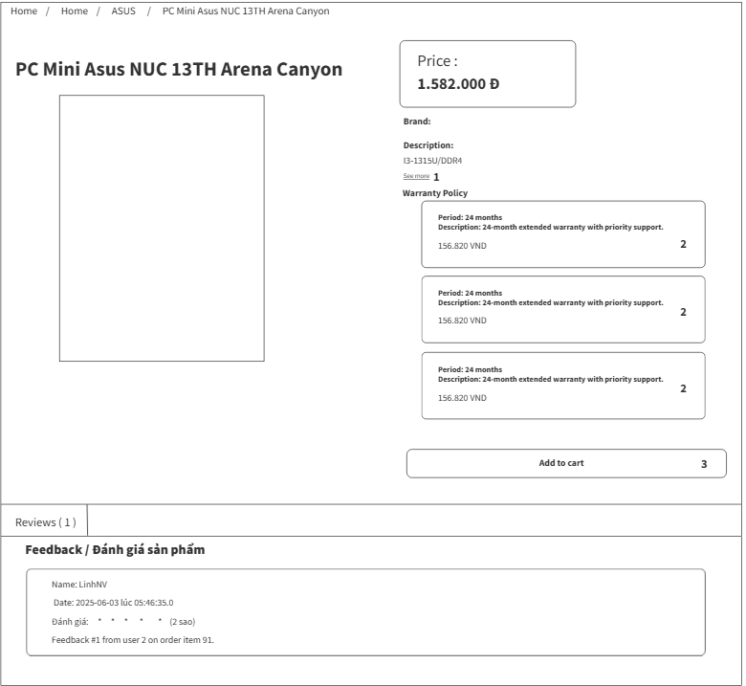

This screen allows the User to:

* **View Product Information**: Display detailed information about the product, including name (PC Mini Asus NUC 13th Arena Canyon), price (1,582,000 VND), and brand.
* **Check Warranty Policy**: Select warranty options (e.g., 24 months extended with priority support) to view details without initial content display, with additional costs (e.g., 150,000 VND for 12 months, 250,000 VND for 24 months).
* **See More Details**: Expand to show additional product details by clicking the "see more" button.
* **Add to Cart**: Add the selected product and chosen warranty to the shopping cart by clicking the "add to cart" button.
* **Navigate**: Use the navigation menu to return to the Home page or other sections.

**Field Description**

| **Field Name** | **Description** |
| --- | --- |
| (1) | Description: see more button  Functions: expands to show additional product details |
| (2) | Description: warranty policy options  Functions: allows selection of warranty periods (e.g., 24 months extended with priority support) without displaying content initially |
| (3) | Description: add to cart button  Functions: adds selected product and warranty to shopping cart |

#### 3.3 Required login Screen

This screen allows the User to:

* **View Sign In Requirement**: Display a notification informing the user that signing in is required to add items to the cart.
* **Sign Up**: Create a new account by clicking the "Sign up" button to access cart functionality.
* **Sign In**: Log in to an existing account by clicking the "Sign in" button to proceed with adding items to the cart.

**Field Description**

| **Field Name** | **Description** |
| --- | --- |
| (1) | Description: sign up button  Functions: redirects to registration page |
| (2) | Description: sign in button  Functions: redirects to login page |

#### 3.4 ViewCategory

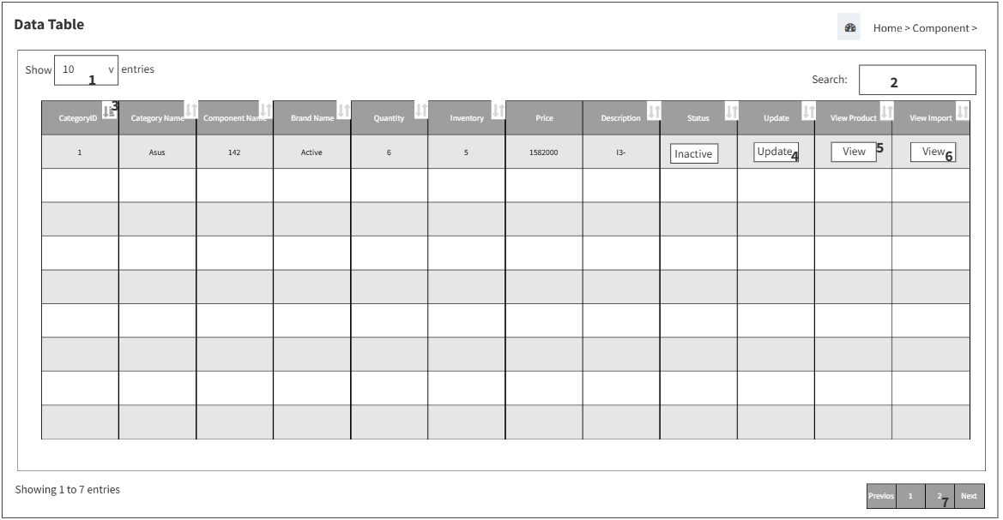

This screen allows users to:

* Update individual records by clicking the **Update** button
* View detailed product information using the **View Product** button
* View component input details through the **View Input** button
* Search for specific records using the **search box**
* Select how many entries to display per page using the **entries dropdown list**
* Sort records by clicking on column headers such as Category ID, Name, Quantity, etc.
* Navigate between pages using **pagination controls**

**Field Description**

| **Field Name** | **Description** |
| --- | --- |
| (1) | Description: Entries dropdown list  Functions: Select how many component records to display per page |
| (2) | Description:Search box  Functions: Search for components by keyword |
| (3) | Description:Sort icons on column headers  Functions: Sort the table by CategoryID, Category Name, Component Name, Brand Name, Quantity, Inventory, Price, Description, Status, Update, View Product, or View Import |
| (4) | Description: Update button  Functions: Access and modify component details |
| (5) | Description:View Product button  Functions:Access detailed product information |
| (6) | Description: View Import button  Functions: Access detailed import information |
| (7) | Description: Pagination controls  Functions: Navigate between pages of component records |

#### 3.5 Update Category.

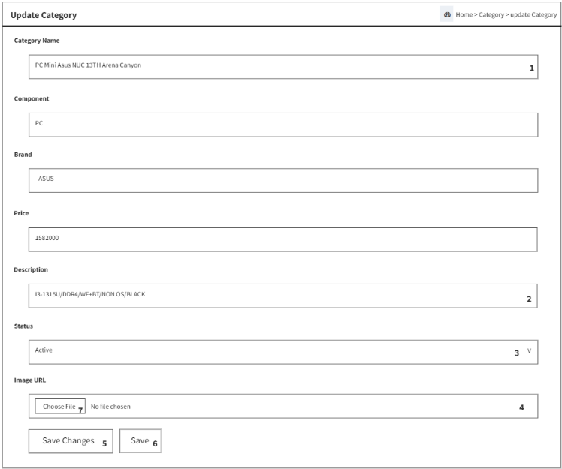

This screen allows **Admin** to:

* Update the category name using the **Category Name** input field
* Select a component using the **Component** dropdown menu
* Choose a brand using the **Brand** dropdown selector
* Enter the **Price** for the category item
* Modify the category **Description** via the text area
* Assign the operational **Status** via dropdown with options:
  + **Inactive** – Temporarily disables the category
  + **Active** – Makes the category available and in use
  + **On Sale** – Flags the category as discounted
  + **Disable** – Permanently disables the category
* Upload an image using the **Choose File** input field
* Save all changes using the **Save Changes** button
* Alternatively, click **Save** to commit updates without applying update logic

**Field Description**

| **Field Name** | **Description** |
| --- | --- |
| (1) | Description: Text input field for Category Name  Functions: Allows Admin to enter the name of the category |
| (2) | Description: Dropdown selector for Component  Functions: Lets Admin select the component type associated with the category |
| (3) | Description: Dropdown selector for Brand  Functions: Enables Admin to choose the brand linked to the category |
| (4) | Description: Numeric input field for Price  Functions: Accepts the price value for the category item |
| (5) | Description: Text area for Description  Functions: Allows Admin to write or modify information about the category |
| (6) | Description: Dropdown menu for Status  Functions: Assigns one of the available status options: Inactive, Active, On Sale, Disable |
| (7) | Description: File input field  Functions: Allows Admin to upload or change the image representing the category |

#### 3.6 Insert Category Screen

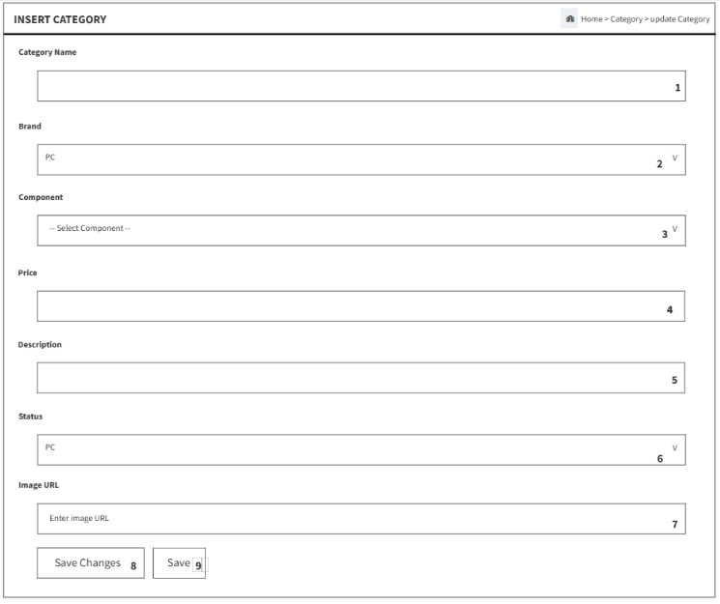

This screen allows **Admin** to:

* Enter the name of a new category via the **Category Name** text input field
* Select a brand name using the **Brand** input field
* Choose a component from the **Component** dropdown menu
* Specify the price of the category item in the **Price** input field
* Fill in additional information using the **Description** text field
* Assign a status via the **Status** dropdown menu with three options:
  + **Active** – Marks the category as available and usable
  + **Inactive** – Indicates the category is temporarily disabled
  + **On Sale** – Highlights the category as currently discounted or promoted
* Input an image link into the **Image URL** text field
* Upload a category image using the **Choose File** button
* Save all changes by clicking the **Save Changes** button
* Alternatively, click **Save** to commit the data entry without applying update logic

**Field Description**

| **Field Name** | **Description** |
| --- | --- |
| (1) | Description: Text input field for entering the category name  Functions: Allows Admin to define a new category label |
| (2) | Description: Text input field for brand name  Functions: Allows Admin to assign a brand to the category |
| (3) | Description: Dropdown menu listing available components  Functions: Allows Admin to select which component belongs to the category |
| (4) | Description: Numeric input field for category price  Functions: Allows Admin to input a monetary value |
| (5) | Description: Text field for category details  Functions: Allows Admin to write information about the category |
| (6) | Description: Dropdown menu with options: Active, Inactive, On Sale  Functions: Allows Admin to choose the operational status of the category |
| (7) | Description: Text input field for adding image link  Functions: Allows Admin to visually represent the category via image |
| (8) | Description: Submission button for all inputs  Functions: Saves the full category entry into the system |
| (9) | Description: Alternate submission option  Functions: Commits the form data without applying “Save Changes” logic |
| (10) | Description: File upload field  Functions: Allows Admin to attach an image file to represent the category visually |

## 4. Build PC Managerment

#### 4.1.1 Home Screen

*\*

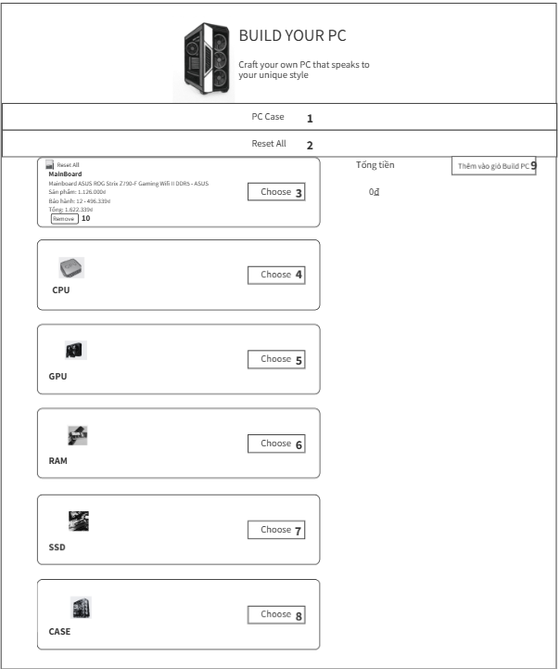

**Field Description**

| **Field Name** | **Description** |
| --- | --- |
| (1) | Description: pc case button  Functions: opens the interface to select a pc case |
| (2) | Description: reset all button  Functions: clears all selected components and resets to the default state |
| (3) | Description: choose button (mainboard)  Functions: select a motherboard to add to the build |
| (4) | Description: choose button (cpu)  Functions: select a cpu to add to the build |
| (5) | Description: choose button (gpu)  Functions: select a graphics card (gpu) to add to the build |
| (6) | Description: choose button (ram)  Functions:select ram to add to the build |
| (7) | Description: choose button (ssd)  Functions: select an ssd to add to the build |
| (8) | Description: choose button (case)  Functions: select a pc case to add to the build |
| (9) | Description: add to build pc cart button  Functions: adds the entire selected pc build to the shopping cart |
| (10) | Description: remove button (mainboard)  Functions: remove the selected motherboard from the build |

### **Description: Build Your PC Screen**

This screen allows the User to:

* **View PC Build**: Display the current PC configuration with selected components like Mainboard, CPU, GPU, RAM, SSD, and Case.
* **Select PC Case**: Open the interface to choose a PC case by clicking the PC case button.
* **Select Components**: Choose specific components by clicking the respective "Choose" buttons to add Mainboard, CPU, GPU, RAM, SSD, and Case to the build.
* **Reset Configuration**: Clear all selected components and reset to the default state by clicking the "Reset All" button.
* **Add to Build Cart**: Add the entire selected PC build to the shopping cart by clicking the "Add to Build PC Cart" button.
* **Remove Component**: Remove the selected Mainboard from the build by clicking the "Remove" button.
* **Craft Unique Style**: Create a personalized PC that reflects the user's unique style based on selected components.

### 

#### 4.1.2 Choose Option Build PC Screen

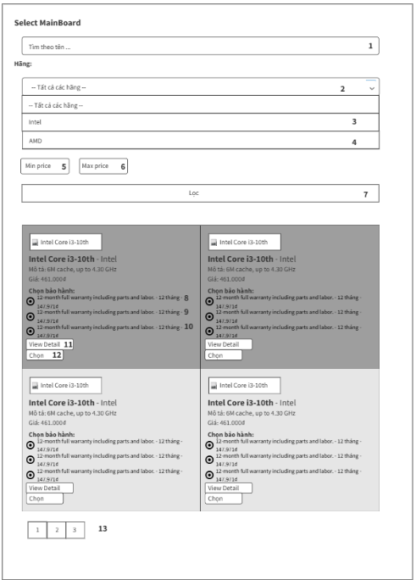

This screen allows the User to:

* **View Mainboard Options**: Display a list of available mainboards (e.g., Intel Core i3-10th, Intel Core i5-10th) with details such as price, warranty, and location.
* **Filter by Brand**: Select between Intel and AMD brands to filter the mainboard options.
* **Set Price Range**: Define a price range using minimum and maximum price inputs to filter mainboards within that range.
* **Search Mainboard**: Enter keywords in the search box to find specific mainboards by name or details.
* **Select Mainboard**: Choose a mainboard by clicking the "Chọn" (Choose) button next to the desired option.
* **Navigate Pages**: Use pagination controls to move between multiple pages of mainboard listings.

**Field Description**

| **Field Name** | **Description** |
| --- | --- |
| (1) | Description: search by name input field  Functions: accepts product name, filters motherboards by name |
| (2) | Description: brand search dropdown  Functions: expands with a downward arrow when clicked, allowing search by brand (e.g., Intel, AMD) |
| (3) | Description: Intel series search dropdown  Functions: allows filtering by Intel series (e.g., i3, i5, i7, i9) |
| (4) | Description: AMD series search dropdown  Functions: allows filtering by AMD series |
| (5) | Description: minimum price input field  Functions: sets minimum price filter |
| (6) | Description: maximum price input field  Functions: sets maximum price filter |
| (7) | Description: filter list button  Functions: applies filters to refine motherboard list |
| (8) | Description: warranty type radio button (1 year)  Functions: selects 1-year warranty option |
| (9) | Description: warranty type radio button (2 years)  Functions: selects 2-year warranty option |
| (10) | Description: warranty type radio button (3 years)  Functions: selects 3-year warranty option |
| (11) | Description: view detail button  Functions: displays detailed product information |
| (12) | Description: select product button  Functions: confirms selection of the motherboard |
| (13) | Description: page navigation button  Functions: switches to the next or previous page of product listings |

## 5. User Managerment

#### 5.1.1 User Profile Screen

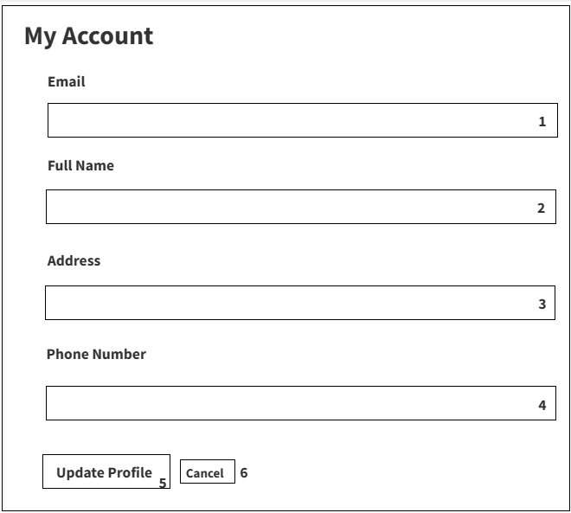

This screen allows the User to:

* **View Account Details**: Display current account information including email, full name, address, and phone number.
* **Edit Email**: Update the email address associated with the account.
* **Edit Full Name**: Update the full name associated with the account.
* **Edit Address**: Update the address associated with the account.
* **Edit Phone Number**: Update the phone number associated with the account.
* **Update Profile**: Save changes to the account details by clicking the "Update Profile" button.
* **Cancel Changes**: Discard any changes and return to the original account details by clicking the "Cancel" button.

**Field Description**

| **Field Name** | **Description** |
| --- | --- |
| (1) | Description: email address input field  Functions: accepts email, validates format |
| (2) | Description: full name input field  Functions: accepts user’s full name |
| (3) | Description: residence location input field  Functions: accepts user’s residence location |
| (4) | Description: phone number input field  Functions: accepts phone number |
| (5) | Description: update profile button  Functions: submits updated profile data |
| (6) | Description: cancel button  Functions: discards changes and returns to view mode |

#### 5.1.2 View Brand Screen

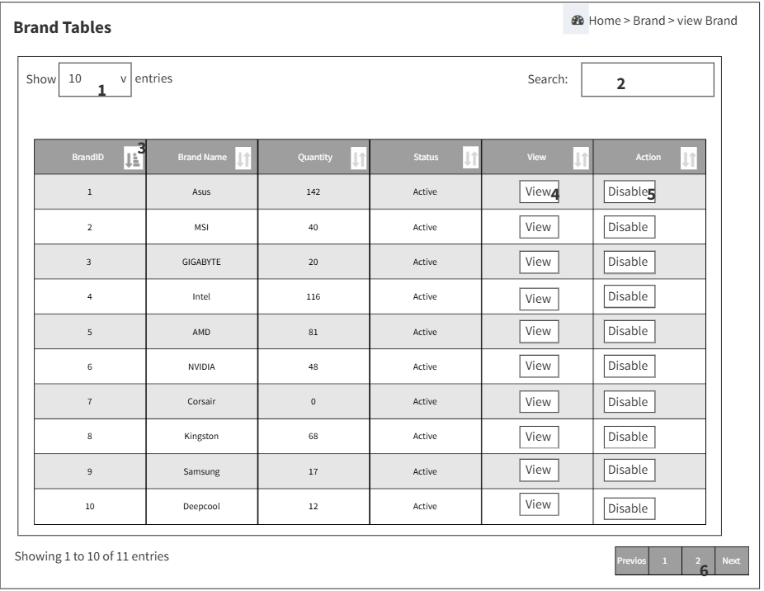

This screen allows users to:

* View a list of brands currently active in the system
* See brand details including Brand ID, Name, Quantity, and Status
* Select how many brand records to display per page using the entries dropdown
* Search for specific brands via keyword using the search box
* Sort the table by Brand ID, Name, Quantity, or Status using column sort icons
* Interact with each brand via **View** and **Disable** action buttons
* Navigate through pages of brand records using pagination controls

**Field Description**

| **Field Name** | **Description** |
| --- | --- |
| (1) | description: entries dropdown list  functions: select how many brand records to display per page |
| (2) | Description: search box  Functions: search for a brand by keyword |
| (3) | Description: sort icons on column headers  Functions: sort the table by brand id, name, quantity, status, etc. |
| (4) | Description: view button  Functions: view detailed information of the selected brand |
| (5) | Description: disable button  Functions: deactivate the selected brand |
| (6) | Description: pagination controls  Functions: navigate between pages of brand records |

## 6. Brand Managerment

#### 6.1.1 View Brand Screen

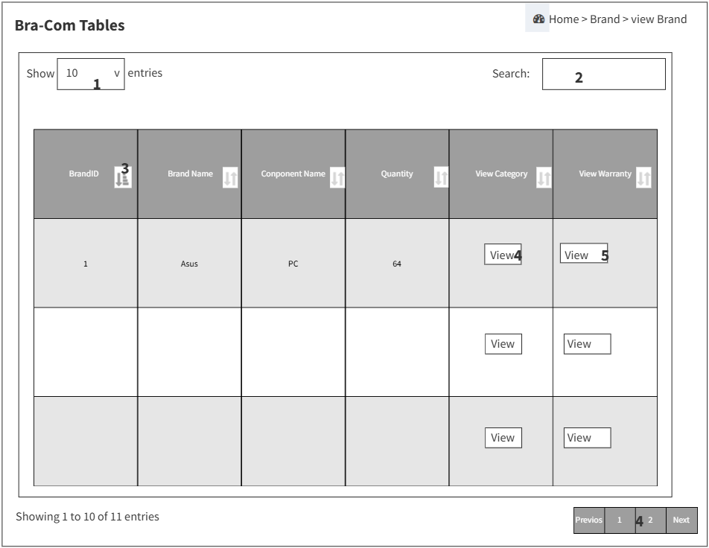

This screen allows users to:

* View a list of brand-component relationships currently active in the system
* See detailed fields including Brand ID, Brand Name, Component Name, Quantity, Category, and Warranty
* Select how many records to display per page using the entries dropdown list
* Search for specific records using keywords in the search box
* Sort the table by clicking column headers (e.g. Brand ID, Name, Quantity) using the sorting icons
* View detailed component category information via the **View Category** button
* View warranty information related to brand components using the **View Warranty** button
* Navigate between pages of brand-component records using pagination controls

| **Field Name** | **Description** |
| --- | --- |
| (1) | Entries dropdown list  Allows users to select the number of brand records displayed per page (e.g., 10, 25, 50...) |
| (2) | Description: search box  Enables quick search for brand records using keywords related to brand name or component |
| (3) | Sort icons on column headers  Allows sorting the table by columns such as BrandID, Brand Name, Component Name, Quantity, etc. |
| (4) | View Category button  Opens a detailed view of the **component category** associated with the selected brand |
| (5) | View Warranty button  Opens detailed **warranty information** for the component of the selected brand |

#### 6.1.2 Insert brand

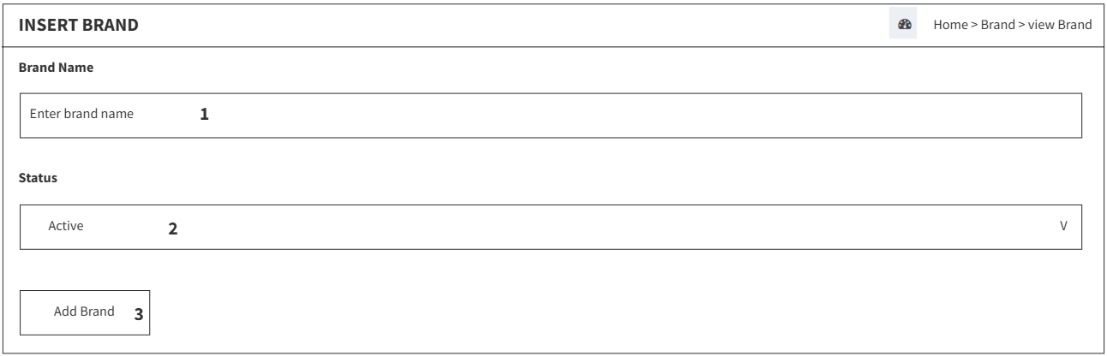

This screen allows users to:

* Enter a new brand name using a text input field
* Select the brand's status (e.g. Active) from a dropdown menu
* Submit the new brand by clicking the **Add Brand** button

**Field Description**

| **Field Name** | **Description** |
| --- | --- |
| (1) | Brand Name field  Input the name of the brand to be added |
| (2) | Status dropdown  Select the status of the brand (Active && Inactive) |
| (3) | Add Brand button  Function: Submit the entered brand information to add it to the system. |

## 7. Brand-Com Managerment

#### 7.1.1 Brand-Com Screen

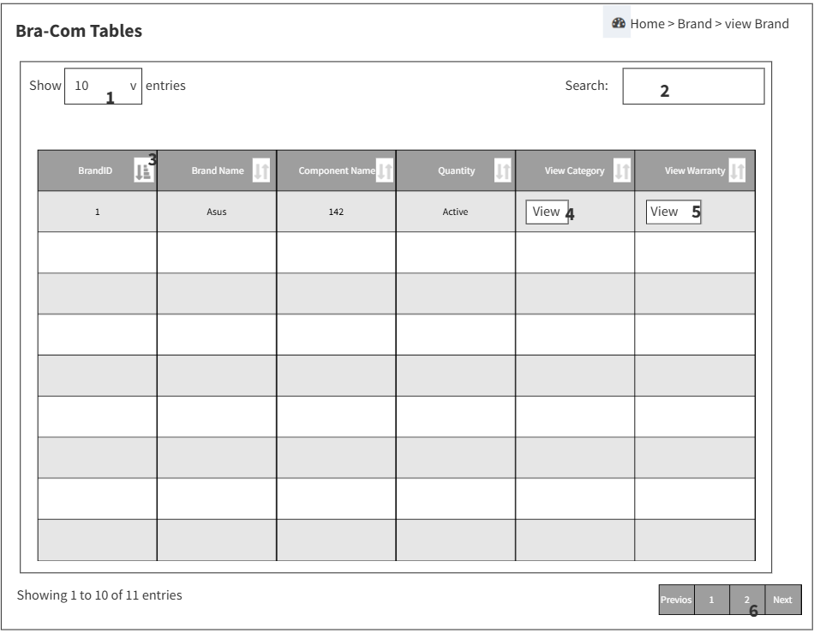

This screen allows users to:

* View a list of brand-component relationships currently stored in the system
* See detailed fields including Brand ID, Brand Name, Component Name, Quantity, Category, and Warranty
* Select how many entries to display per page via the entries dropdown
* Filter brand-component data using the search box with keyword input
* Sort the table using icons on column headers (Brand ID, Name, Quantity, etc.)
* View category information for specific components using the **View Category** button
* View warranty details for components using the **View Warranty** button
* Navigate across multiple pages of data using pagination control

| **Field Name** | **Description** |
| --- | --- |
| (1) | description: entries dropdown list  functions: select how many brand records to display per page |
| (2) | Description: search box  Functions: search for a brand by keyword |
| (3) | Description: sort icons on column headers  Functions: sort the table by brand id, name, quantity, status, etc. |
| (4) | Description: view button  Functions: view detailed information of the selected brand |
| (5) | Description: disable button  Functions: deactivate the selected brand |
| (6) | Description: pagination controls  Functions: navigate between pages of brand records |

#### 7.1.3 Insert Bra-Com Screen

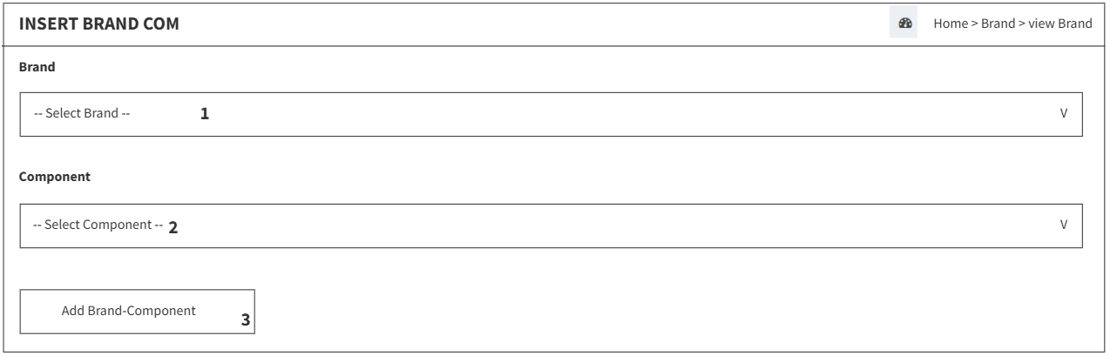

This screen allows **Admin** to:

* Select a brand name from the dropdown menu, with available options including:
  + **ASUS**, **MSI**, **GIGABYTE**, **Intel**, **AMD**, **NVIDIA**, **Corsair**, **Kingston**, **Samsung**, **DeepCool**, **WesternDigital**
* Select a component type from the dropdown menu, which includes:
  + **PC**, **MainBoard**, **CPU**, **GPU**, **RAM**, **SSD**, **Case**
* Click the **Add Brand-Component** button to link the selected brand with the chosen component

| **Field Name** | **Description** |
| --- | --- |
| (1) | Description: Dropdown selector listing available brands (e.g., ASUS, MSI, GIGABYTE, etc.)  Functions: Allows Admin to choose a brand from the list |
| (2) | Description: Dropdown selector listing component types (e.g., PC, CPU, RAM, SSD, etc.)  Functions: Allows Admin to select a component to associate with the chosen brand |
| (3) | Description: Submission button to confirm selection  Functions: Saves the relationship between the selected brand and component |

## 8. Component Managerment

#### 8.1.1 View Conponent Screen

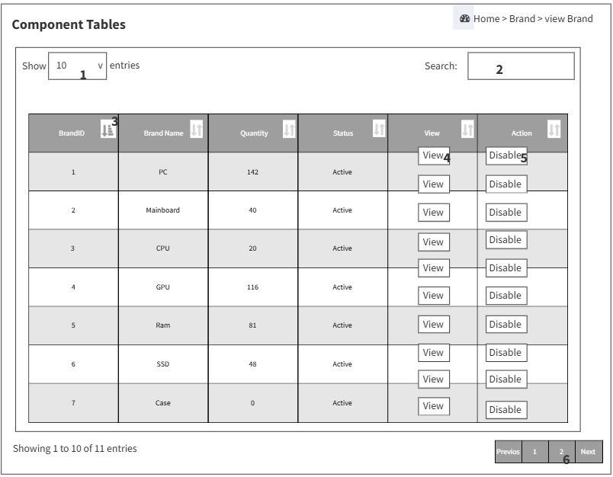

This screen allows **Admin** to:

* View the ID of each component brand
* See the name of the brand displayed in the table
* Check current inventory quantity for each brand
* Identify the status of each brand, such as whether it's Active or Disabled
* Open detailed product information using the **View** button
* Deactivate a brand entry using the **Disable** button

| **Field Name** | **Description** |
| --- | --- |
| (1) | Description: Identifier for the component brand  Functions: Displays the brand's unique ID |
| (2) | Description: Label showing the name of the brand  Functions: Displays the name of the component brand |
| (3) | Description: Numeric field showing available stock  Functions: Shows how many units of the brand are currently in inventory |
| (4) | Description: Badge or dropdown indicating brand state  Functions: Displays whether the brand is Active or Disabled |
| (5) | Description: Button for accessing brand details  Functions: Opens detailed product information for that brand |
| (6) | Description: Button to deactivate a brand entry  Functions: Sets the brand status to Disabled |

#### 8.1.2 Insert Conponent Screen

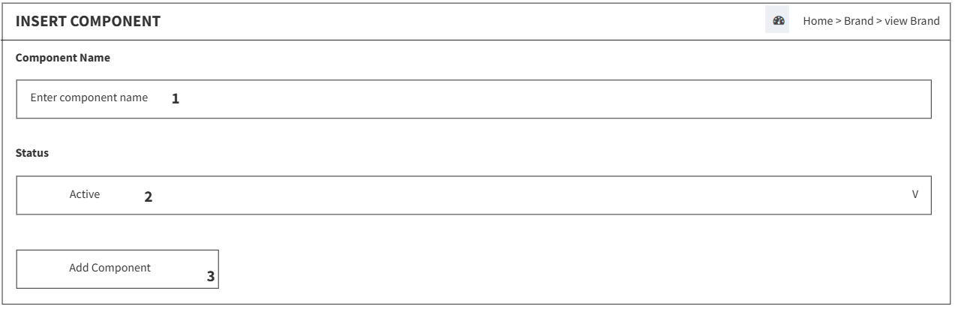

This screen allows **Admin** to:

* Enter the name of a new component via the **Component Name** input field
* Assign a status to the component using the **Status** dropdown (Active or Inactive)
* Click the **Add Component** button to submit the new entry into the system

| **Field Name** | **Description** |
| --- | --- |
| (1) | Description: Text input field for entering the component name  Functions: Allows Admin to type the name of the new component |
| (2) | Description: Dropdown menu with two options: Active and Inactive  Functions: Allows Admin to assign a status indicating availability |
| (3) | Description: Submission button  Functions: Saves the new component with selected values into the system |

## 9. Product Managerment

#### 9.1.1 View Product Screen

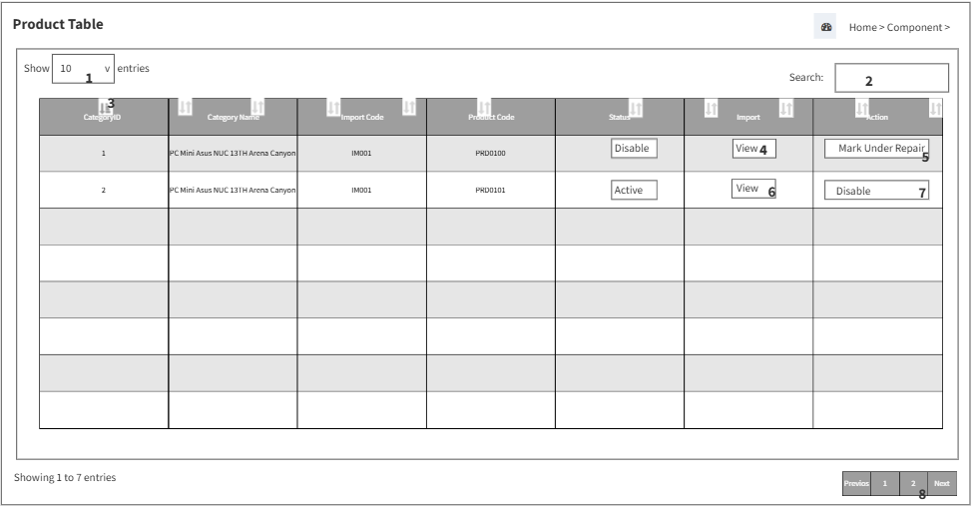

This screen allows **Admin** to:

* Control how many entries are visible in the table using **Show Entries**
* Search for products by typing into the **Search** input field
* Sort product data by clicking the header of any column such as Category ID, Import Code, or Status
* View details for a product by clicking the **View** button under the Import column
* Mark a product as under maintenance using the **Mark Under Repair** button
* Disable a product using the **Disable** button in the Action column
* Navigate through product pages using the **Pagination** controls

| **Field Name** | **Description** |
| --- | --- |
| (1) | Description: Dropdown to choose how many rows are displayed  Functions: Allows Admin to control number of products shown per page |
| (2) | Description: Text input field for product filtering  Functions: Allows Admin to search and narrow down results by keyword |
| (3) | Description: Clickable table headers  Functions: Allows Admin to reorder products based on selected column |
| (4) | Description: Button labeled “View” under Import column  Functions: Opens full import details of the selected product |
| (5) | Description: Button labeled “Disable” in Action column  Functions: Sets the selected product status to Disabled |
| (6) | Description: Button labeled “View” under Import column  Functions: Opens full import details of the selected product |
| (7) | Description: Button labeled “Mark Under Repair”  Functions: Flags the product as requiring maintenance |
| (8) | Description: Navigation controls below the table  Functions: Allows Admin to move across pages of product listings |

#### 9.1.2 View Product Button Screen

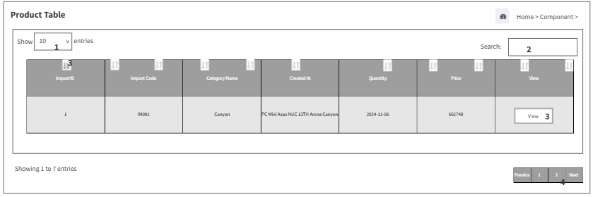

This screen allows **Admin** to:

* Control how many import entries are displayed using **Show Entries**
* Search for specific import records using the **Search** input field
* Sort the table by clicking on column headers such as Import ID, Category, Quantity, or Price
* View detailed information for each import record using the **View** butto

| **Field Name** | **Description** |
| --- | --- |
| (1) | Description: Dropdown selector for number of rows shown  Functions: Allows Admin to choose how many import records are displayed per page |
| (2) | Description: Text input field for filtering import entries  Functions: Allows Admin to search imports based on keywords |
| (3) | Description: Clickable headers of table columns  Functions: Allows Admin to reorder import list based on selected column |
| (4) | Description: Button labeled “View” at end of each row  Functions: Opens detailed view of the selected import record |

## 10. Warranty Managerment

#### 10.1.1 View Warranty Screen

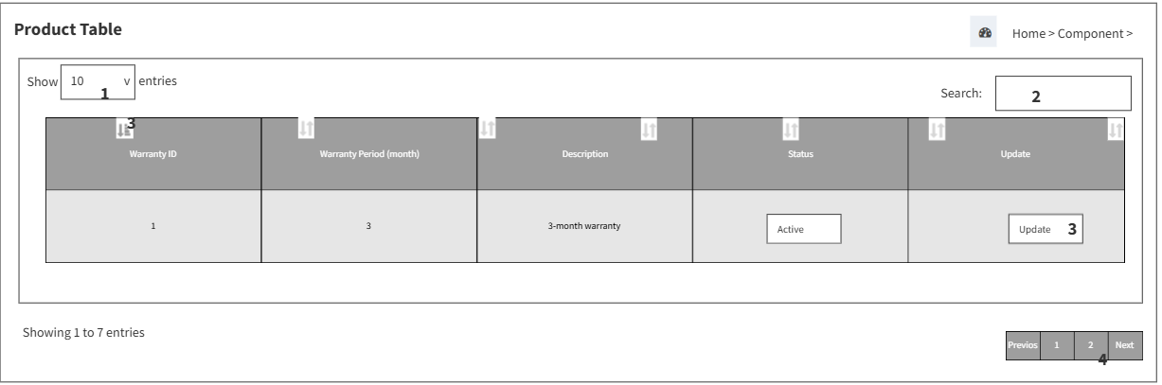

This screen allows **Admin** to:

* Control how many warranty records are displayed using **Show Entries**
* Search for warranties with keywords entered in the **Search** input field
* View and navigate pages using **Pagination controls** (Previous, 1, 2, Next)
* Click the **Update** button to edit warranty details directly from the table

| **Field Name** | **Description** |
| --- | --- |
| (1) | Description: Dropdown selector for number of rows displayed  Functions: Allows Admin to control how many warranty records appear per page |
| (2) | Description: Text input field for keyword search  Functions: Allows Admin to filter warranty records by keyword |
| (3) | Description: Page navigation controls below the table  Functions: Allows Admin to move across multiple pages of warranty entries |
| (4) | Description: Action button labeled “Update”  Functions: Opens warranty record for editing directly from the row |

#### 10.1.2 Update Warranty Button Screen

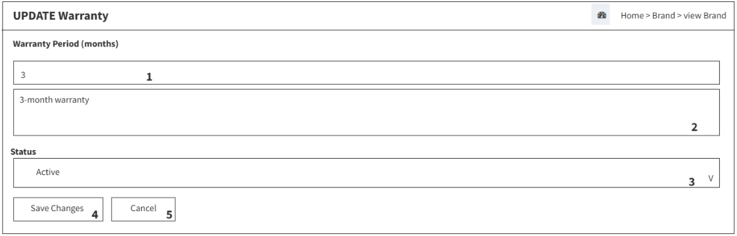

This screen allows **Admin** to:

* View the **Import Code** of the product being updated
* Specify the warranty duration using the **Warranty Period (months)** input field
* Choose a warranty status from the **Status** dropdown menu
* Confirm the updates by clicking the **Save Changes** button
* Cancel the update process using the **Cancel** button

| **Field Name** | **Description** |
| --- | --- |
| (1) | Description: Read-only label showing product’s import identifier  Functions: Displays the import reference linked to the product’s warranty |
| (2) | Description: Numeric input for warranty duration  Functions: Allows Admin to specify warranty length in months |
| (3) | Description: Dropdown selector for warranty state  Functions: Allows Admin to set the warranty as Active or Inactive |
| (4) | Description: Action button to confirm update  Functions: Commits updated warranty information to the system |
| (5) | Description: Action button to abort changes  Functions: Discards edits and returns to warranty list |

### 

#### 10.1.3 Insert Warranty Screen

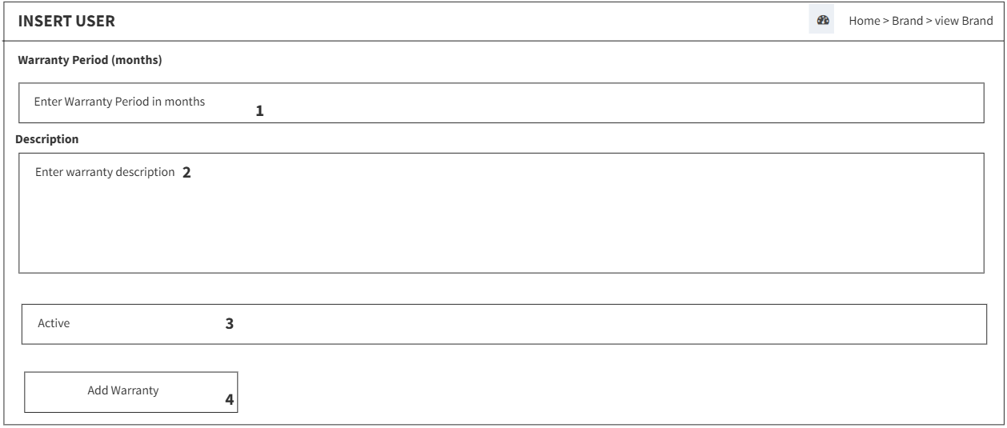

This screen allows **Admin** to:

* Enter the warranty period using the **Warranty Period (months)** input field
* Provide additional information in the **Description** text area
* Set the status of the warranty with the **Active** checkbox
* Submit the entry using the **Add Warranty** button

| **Field Name** | **Description** |
| --- | --- |
| (1) | Description: Numeric input for warranty duration  Functions: Allows Admin to define how many months the warranty lasts |
| (2) | Description: Text field for warranty notes  Functions: Allows Admin to provide additional details about the warranty |
| (3) | Description: Checkbox to set warranty status  Functions: Allows Admin to mark warranty as active or inactive |
| (4) | Description: Action button to confirm entry  Functions: Submits the new warranty record to the system |

### 

### 

#### 10.1.4 Warranty Details Table Screen

### 

This screen allows **Admin** to:

* Control how many warranty detail entries are displayed using the **Show Entries** dropdown
* Search for specific warranty records using the **Search** input field
* Sort the warranty list by clicking column headers like Component, Brand, or Status
* Update warranty details directly by clicking the **Update** button
* Navigate through pages using the **Pagination** controls

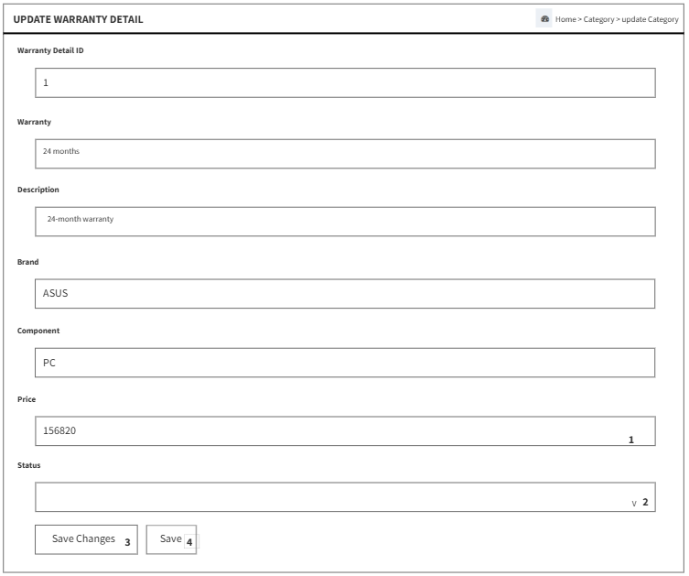

This screen allows **Admin** to:

* Enter the price using the **Price** input field
* Toggle the warranty detail status between **Inactive** and **Active** using the **Status** dropdown
* Apply changes using the **Save Changes** button
* Save directly using the **Save** button

## 11. Order Management

### 11.1 Order Category Management

#### 11.1.1 Order Category Checkout

#### 11.1.2 Order Category History

#### 11.1.3 Order Category History Detail

#### 11.1.4 Order Category Pending

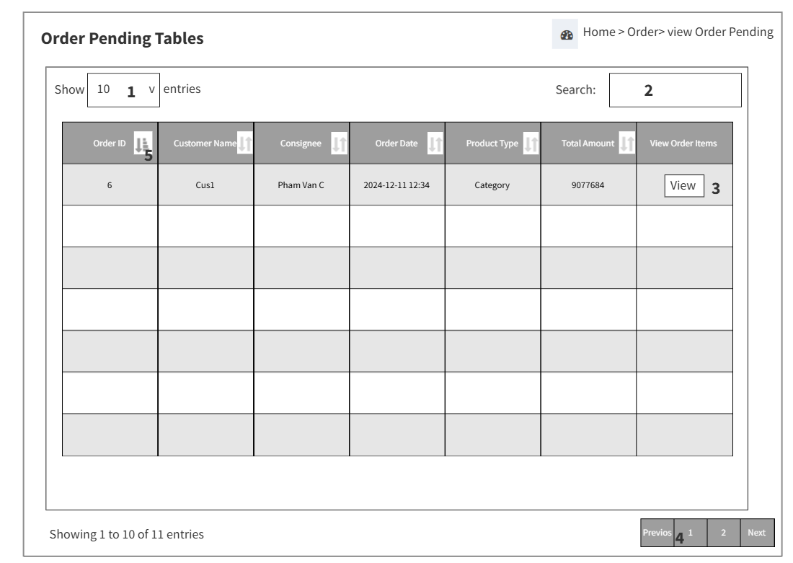

This screen allows **Staff**  to:

* View a list of basic information contained in a specific customer order
* View detail fields including Order ID, Order Code,Customer Name, Consignee, OrderDate, Product_Type, Total Amount
* Select the number of records to display the number of PC in one page using t
* Search for specific order items using keywords in the search box
* Sort the table by clicking on the column headers (e.g. Order ID, Customer Name) using the sort icons
* View item information using the View Order Items button
* Navigate between order record pages using the pagination controls

| **Field Name** | **Description** |
| --- | --- |
| (1) | description: entries dropdown list  functions: select how many order records to display per page |
| (2) | Description: search box  Functions: search for a order by keyword |
| (3) | Description: sort icons on column headers  Functions: sort the table by orderID, OrderCode, etc. |
| (4) | Description: pagination controls  Functions: navigate between pages of order records |
| (5) | Description: Button labeled “View” at end of each row  Functions: Opens Order Items view of the selected order record |

#### 11.1.5 Order Category Reject

#### 11.1.6 Order Category On Process

#### 11.1.7 Order Category Wait Ship

#### 11.1.9 Order Category On Ship

#### 11.1.10 Order Category Complete

#### 11.1.11 Order Category Pending Warranty

#### 11.1.12 Order Category Warranty

### 11.2 Order Item and Detail Category Management

#### 11.2.1 Order Item Category Pending

#### 11.2.2 Order Item Category Complete

#### 11.2.3 Order Item Category On Ship

#### 11.2.4 Order Item Category Wait Ship

#### 11.2.5 Order Item Category Process

### 

### 

### 

### 12 Build PC Management

12.1.1 Build PC List management

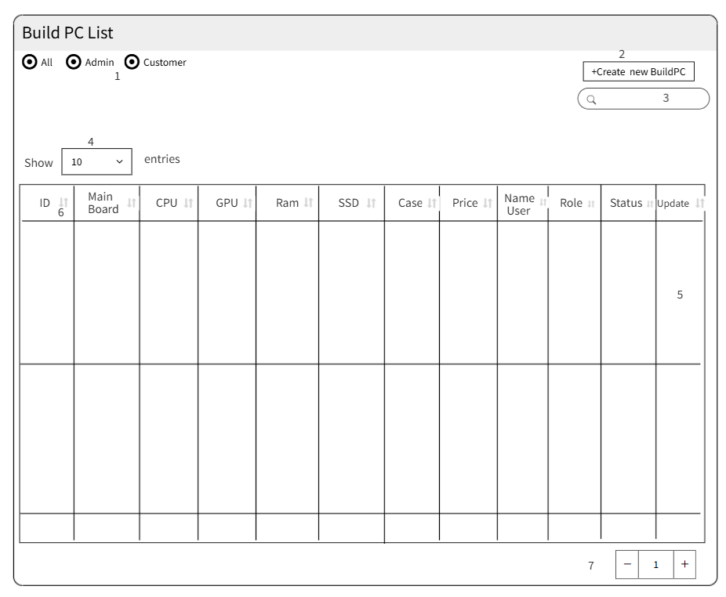

### Build PC Management allow admin to do:

* View list PC have been builded by customer and admin.
* View details of PC have ID, Main Board, CPU, RAM, SSD, CASE,Price,Name User,Role,Status.
* Radio to filter Roles of Pc to see that PC of Roles user
* Button to click to create new PC with roles Admin.
* Search for specific PC items using keywords in the search box
* Select to changes the number of PC in one Pages
* Update button for Pc have role admin to changes category and status.
* Sort the table by clicking on the column headers (e.g. Order ID, Customer Name) using the sort icons.
* A Spinner to changes pages

| **Field Name** | **Description** |
| --- | --- |
| (1) | description: entries dropdown list  functions: select how many order records to display per page |
| (2) | Description: Button create  Functions: To create new PC with roles is admin |
| (3) | Description: search box  Functions: search for a order by keyword |
| (4) | Description: pagination controls  Functions: navigate between pages of order records |
| (5) | Description: Button labeled “Update” at end of each row have role Admin  Functions: Opens to Update PC with Role Admin |
| (6) | Description: sort icons on column headers  Functions: sort the table by PC ID, User of Pc…. |
| (7) | Description: pagination controls  Functions: navigate between pages of order records |

#### 

#### 

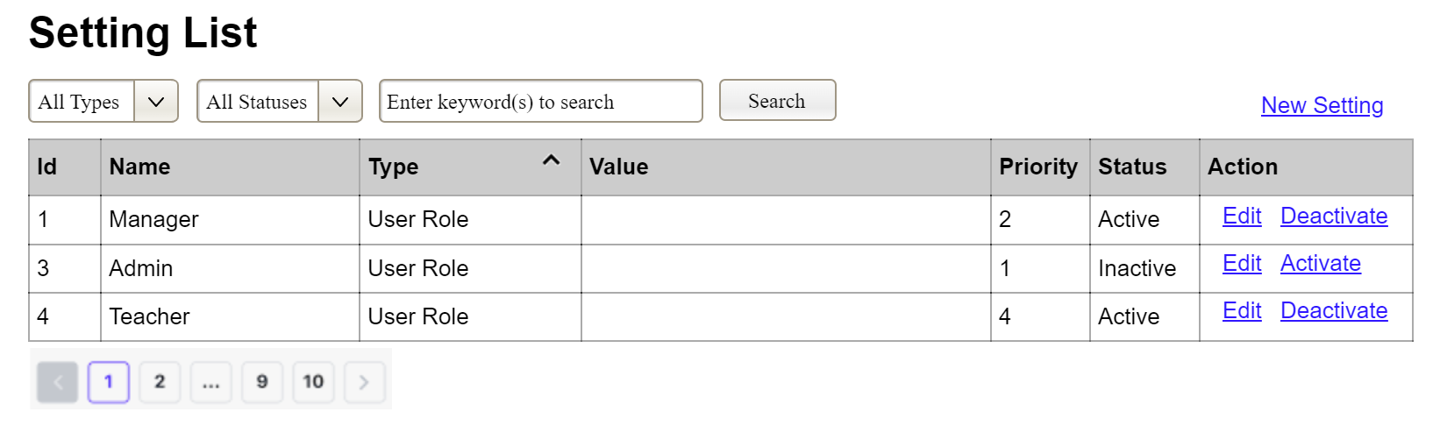

This screen allows the Administrator to:

* View Setting List: view list of current master data.
* Filter Setting List: filter master data by data types, statuses
* Search Settings: enter keyword(s) to search master data by their names or values
* Sort Setting List: sort mater data list (ascending, descending) by clicking column headers

On the screen, s/he can also

* Activate/Deactivate Setting: change status of a specific inactive/active master data
* Choose to go to the Setting Details screens for adding new or updating an existing master data by clicking the New Setting or Edit link.

**Field Description**

| **Field Name** | **Description** |
| --- | --- |
| (1) | Initial values: all the active setting names with null or blank type  Hover the mouse to show the field name: “Setting Type” |
| (2) | Initial values: All Statuses, Active, Inactive (default value “All Status”)  Hover the mouse to show the field name: “Setting Status” |
| (3) | The change-status action is Activate or Deactivate depending on the current status of the relevant setting (Inactive or Active, respectively). |

#### 3.1.2 Setting Details

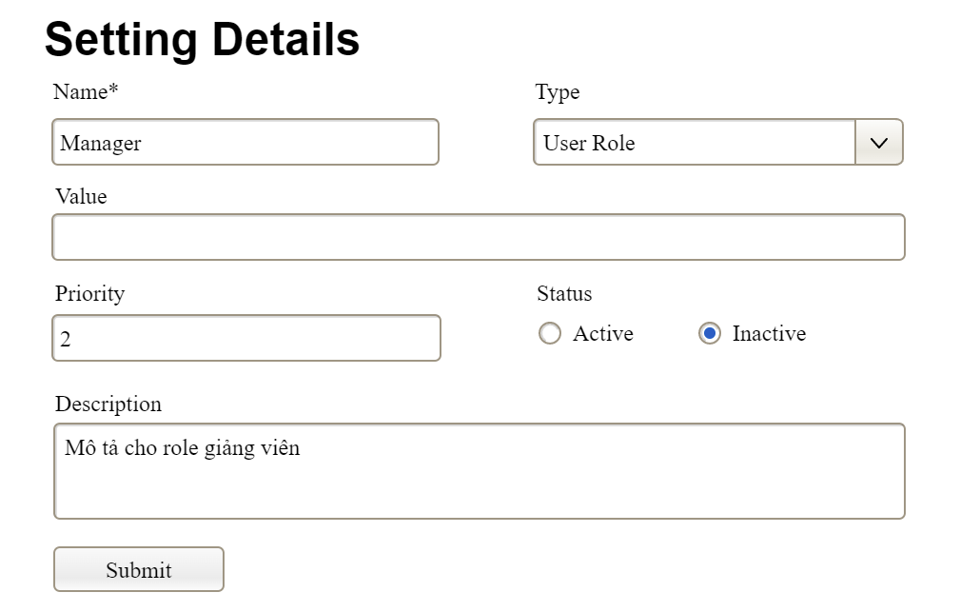

This screen allows the Administrator to:

* Add New Setting: add new master data.
* Update Setting Details: update details of a specific master data

**Field Description**

| **Field Name** | **Description** |
| --- | --- |
| Name | Data type: non-digit string, max length of 20 characters |
| Type | Initial data values: all active setting names (with null or blank type) |
| Value | Data type: any string, max length of 100 characters |
| Priority | Data type: a positive integer |
| Description | Data type: any string, max length of 200 characters |

### 3.3 Order Build PC Management

#### 3.2.1 User List

…

#### 3.2.2 User Details

…

# III. System Design

## 1. Database Design

*[Provide the tables relationship like example below]*

### 1.1 Database Schema

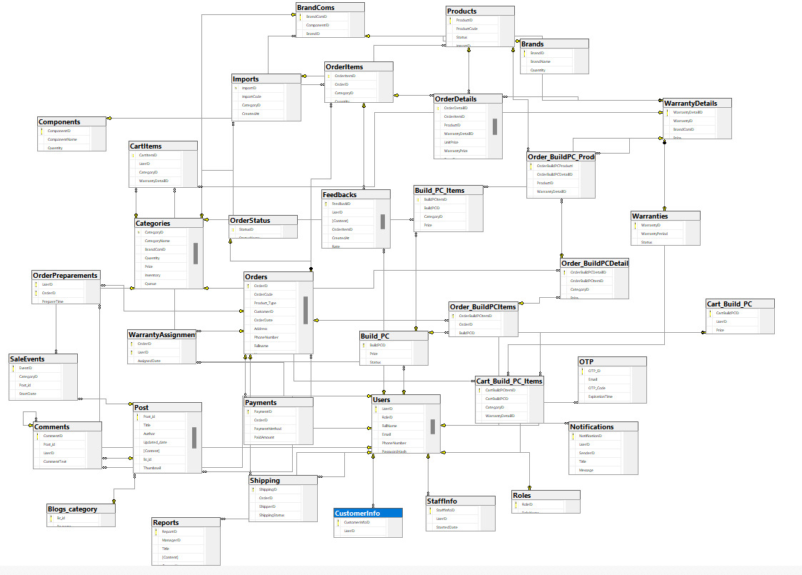

### 1.2 Table Descriptions

| No | Table | Description |
| --- | --- | --- |
| 01 | Roles | Contains system roles.  - Primary keys: RoleID  - Foreign keys: None  - Unique keys: RoleName |
| 02 | Users | Stores user accounts and login credentials.  - Primary keys: UserID  - Foreign keys: RoleID → Roles(RoleID)  - Unique keys: Email |
| 03 | CustomerInfo | Additional info for customer users.  - Primary keys: CustomerInfoID  - Foreign keys: UserID → Users(UserID)  - Unique keys: None |
| 04 | StaffInfo | Staff working period details.  - Primary keys: StaffInfoID  - Foreign keys: UserID → Users(UserID)  - Unique keys: None |
| 05 | Components | Component types (e.g., CPU, RAM).  - Primary keys: ComponentID  - Foreign keys: None  - Unique keys: ComponentName |
| 06 | Brands | Contains brand details.  - Primary keys: BrandID  - Foreign keys: None  - Unique keys: None |
| 07 | BrandComs | Associates brands with components.  - Primary keys: BrandComID  - Foreign keys: ComponentID → Components(ComponentID), BrandID → Brands(BrandID)  - Unique keys: None |
| 08 | Categories | Product categories (linked to BrandCom).  - Primary keys: CategoryID  - Foreign keys: BrandComID → BrandComs(BrandComID)  - Unique keys: CategoryName |
| 09 | Imports | Import records for stock updates.  - Primary keys: ImportID  - Foreign keys: CategoryID → Categories(CategoryID)  - Unique keys: None |
| 10 | Products | Individual product units.  - Primary keys: ProductID  - Foreign keys: ImportID → Imports(ImportID)  - Unique keys: None |
| 11 | Warranties | Warranty configuration.  - Primary keys: WarrantyID  - Foreign keys: None  - Unique keys: None |
| 12 | WarrantyDetails | Warranty info for each BrandCom.  - Primary keys: WarrantyDetailID  - Foreign keys: WarrantyID → Warranties(WarrantyID), BrandComID → BrandComs(BrandComID)  - Unique keys: None |
| 13 | Orders | Customer orders (item/build).  - Primary keys: OrderID  - Foreign keys: CustomerID → Users(UserID), Status → OrderStatus(StatusID)  - Unique keys: None |
| 14 | OrderItems | Items associated with Orders.  - Primary keys: OrderItemID  - Foreign keys: OrderID → Orders(OrderID), CategoryID → Categories(CategoryID)  - Unique keys: None |
| 15 | OrderDetails | Detailed product info for orders.  - Primary keys: OrderDetailID  - Foreign keys: OrderItemID → OrderItems(OrderItemID), ProductID → Products(ProductID), WarrantyDetailID → WarrantyDetails(WarrantyDetailID)  - Unique keys: None |
| 16 | CartItems | User's cart contents.  - Primary keys: CartItemID  - Foreign keys: UserID → Users(UserID), CategoryID → Categories(CategoryID), WarrantyDetailID → WarrantyDetails(WarrantyDetailID)  - Unique keys: None |
| 17 | Shipping | Shipping info per order.  - Primary keys: ShippingID  - Foreign keys: OrderID → Orders(OrderID), ShipperID → Users(UserID)  - Unique keys: None |
| 18 | Feedbacks | User feedback for products/orders.  - Primary keys: FeedbackID  - Foreign keys: UserID → Users(UserID), OrderItemID → OrderItems(OrderItemID)  - Unique keys: None |
| 19 | Reports | Reports submitted by managers.  - Primary keys: ReportID  - Foreign keys: ManagerID → Users(UserID)  - Unique keys: None |
| 20 | Payments | Payment records for orders.  - Primary keys: PaymentID  - Foreign keys: OrderID → Orders(OrderID)  - Unique keys: None |
| 21 | Blogs_category | Categories for blog posts.  - Primary keys: Bc_id  - Foreign keys: None  - Unique keys: None |
| 22 | Post | Blog post content and metadata.  - Primary keys: Post_id  - Foreign keys: Bc_id → Blogs_category(Bc_id), Add_id → Users(UserID)  - Unique keys: None |
| 23 | SaleEvents | Product discount event info.  - Primary keys: EventID  - Foreign keys: CategoryID → Categories(CategoryID), Post_id → Post(Post_id)  - Unique keys: None |
| 24 | OrderPreparements | Tracks staff preparing orders.  - Primary keys: (UserID, OrderID)  - Foreign keys: UserID → Users(UserID), OrderID → Orders(OrderID)  - Unique keys: None |
| 25 | OTP | Stores OTP codes for email validation.  - Primary keys: OTP_ID  - Foreign keys: Email → Users(Email)  - Unique keys: None |
| 26 | Build_PC | Custom PC builds per user.  - Primary keys: BuildPCID  - Foreign keys: UserID → Users(UserID)  - Unique keys: None |
| 27 | Build_PC_Items | Items in a custom-built PC.  - Primary keys: BuildPCItemID  - Foreign keys: BuildPCID → Build_PC(BuildPCID), CategoryID → Categories(CategoryID), WarrantyDetailID → WarrantyDetails(WarrantyDetailID)  - Unique keys: None |
| 28 | Cart_Build_PC | Custom PC cart per user.  - Primary keys: CartBuildPCID  - Foreign keys: UserID → Users(UserID)  - Unique keys: None |
| 29 | Cart_Build_PC_Items | Items inside a Build PC cart.  - Primary keys: CartBuildPCItemID  - Foreign keys: CartBuildPCID → Cart_Build_PC(CartBuildPCID), CategoryID → Categories(CategoryID), WarrantyDetailID → WarrantyDetails(WarrantyDetailID)  - Unique keys: None |
| 30 | Comments | User comments on blog posts.  - Primary keys: CommentID  - Foreign keys: Post_id → Post(Post_id), UserID → Users(UserID), ParentCommentID → Comments(CommentID)  - Unique keys: None |
| 31 | Order_BuildPCItems | Build PC orders for users.  - Primary keys: OrderBuildPCItemID  - Foreign keys: OrderID → Orders(OrderID), BuildPCID → Build_PC(BuildPCID)  - Unique keys: None |
| 32 | Order_BuildPCDetails | Detailed parts in Build PC order.  - Primary keys: OrderBuildPCDetailID  - Foreign keys: OrderBuildPCItemID → Order_BuildPCItems(OrderBuildPCItemID), CategoryID → Categories(CategoryID)  - Unique keys: None |
| 33 | Order_BuildPC_Products | Physical products linked to Build PC order details.  - Primary keys: OrderBuildPCProductID  - Foreign keys: OrderBuildPCDetailID → Order_BuildPCDetails(OrderBuildPCDetailID), ProductID → Products(ProductID), WarrantyDetailID → WarrantyDetails(WarrantyDetailID)  - Unique keys: None |
| 34 | Notifications | User notification messages.  - Primary keys: NotificationID  - Foreign keys: UserID → Users(UserID), SenderID → Users(UserID)  - Unique keys: None |
| 35 | WarrantyAssignments | Staff assigned to handle warranties.  - Primary keys: (OrderID, UserID)  - Foreign keys: OrderID → Orders(OrderID), UserID → Users(UserID)  - Unique keys: None |
| 36 | OrderStatus | Status for Order.  - Primary keys: (StatusID)  - Foreign keys: None  - Unique keys: None |

## 2. Code Packages

*[Provide the package diagram for the system (or sub systems) and package description similar to sample diagram and using description table format below]*

### 2.1 Package Diagram

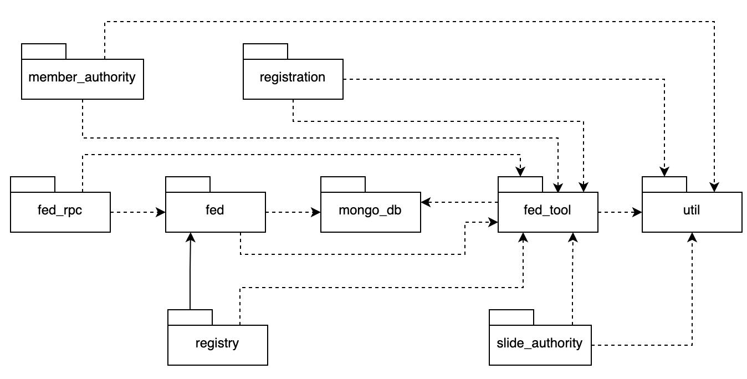

### 2.2 Package Descriptions

| **No** | **Package** | **Description** |
| --- | --- | --- |
| *01* | *member_authority* | *<Description of the package: purpose, contents,..>* |
| *02* | *registration* | *<Description of the package: purpose, contents,..>* |
| *03* | *…* |  |

https://docs.google.com/spreadsheets/d/1Pmg4EBwsinWOYcHEkftLURnjt4gOBr3q/edit?gid=1920911076#gid=1920911076